

**BIOlogical Factors that Limit sustAined Remission in rhEumatoid arthritis**

**The BIO-FLARE Study**

**Blood and Urine Sample Processing SOP Manual**



|  |  |  |
| --- | --- | --- |
| **Version History** | | |
| **Version** | **Date** | **Reason for change** |
| 1.0 |  |  |
|  |  |  |
|  |  |  |
|  |  |  |
|  |  |  |

|  |  |  |  |
| --- | --- | --- | --- |
|  | **Name** | **Signature** | **Date** |
| **Compiled by:** | Amy E. Anderson |  |  |
| Oliver Eltherington |  |  |
| David Swan |  |  |
|  |  |  |
| **Approved by PI:** |  |  |  |
| **CI acceptance:** | John D. Isaacs |  |  |
| **Review date:** |  | | |

**Table of contents**

***Page 4* 1. Study background**

***Page 5`* 2. Purpose**

***Pages 5 - 8* 3. Study overview and summary sample collection schedule**

***Pages 9 -*  4. BIO-FLARE** **cytokine reconstitution and storage for Smart Tube stimulation SOP (BIO-FLARE SOP 006)**

***Pages*  5.** **BIO-FLARE Smart Tube stabilisation and storage of heparin blood SOP (BIO-FLARE SOP 007)**

***Pages*  6. BIO-FLARE serum and urine sample separation and storage SOP (BIO-FLARE SOP 008)**

***Pages*  7. BIO-FLARE Tempus Blood RNA tube storage SOP (BIO-FLARE 009)**

***Pages*  8. BIO-FLARE preparation and storage of peripheral blood mononuclear cells SOP (BIO-FLARE SOP 010)**

***Pages*  9. BIO-FLARE isolation of cell subsets (monocytes and CD4+ T cells) using the Miltenyi MACS system SOP (BIO-FLARE SOP 011)**

***Pages*  10. Appendices**

1. **Study background**

* The BIO-FLARE study is a Medical Research Council (MRC) Experimental Medicine Challenge grant between three centres - Newcastle University, University of Birmingham, and University of Glasgow
* The objective of the BIO-FLARE study is to address why immune-mediated inflammatory diseases (IMIDs), such as rheumatoid arthritis (RA), remit and relapse (flare). Our focus will be on systemic immune dysregulation and local dysregulation of synovial fibroblasts, which includes the investigation of epigenetic factors and changes in systemic or localised metabolism.
* We will use an established human model of a ‘synchronized’ population of RA patients in clinical remission:
  + When treatment is stopped in these patients approximately 50% will relapse within 6 months, the remainder maintain remission
* To interrogate the biology of disease flare and identify factors that trigger flares we will focus on:
  + Circulating immune cell subsets and their activation status
  + Autoantibody profiles (partnering with Orgentec) and other circulating mediators
  + Synovium, including stromal cell subtypes
  + Metabolic profiles related to immune and/or synovial activation (with the Phenome Centre)
  + Epigenetic profiles (partnering with Oxford Biodynamics)
* Our hypothesis is that, consequent upon epigenetic influences, systemic immune factors integrate with the articular stromal compartment to provoke localised flare, supported and sustained by metabolic changes in the joint.

1. **Purpose**

* The purpose of this standard operating procedure (SOP) manual is to describe the procedures to collect and process the study blood samples, urine, stool and synovial biopsies for the BIO-FLARE study.
* To minimize the errors connected with the pre-analytical phase of the research process. The pre-analytical phase includes all events affecting the quality of the sample including preparation of the patient for the sample collection, how the sample was collected, transported and fractionated.

1. **Study overview and summary sample collection schedule**

* Recruitment will be split over the three centres (Newcastle University, University of Birmingham, and University of Glasgow) with each centre expected to recruit 55 patients each (from which 10% are estimated to be lost to follow-up) (see ***Figure 3.1***)

**N.B.** The biological samples collected from patients lost to follow-up will be used as quality controls for assessing sample processing and should be processed and stored as per the relevant SOPs.

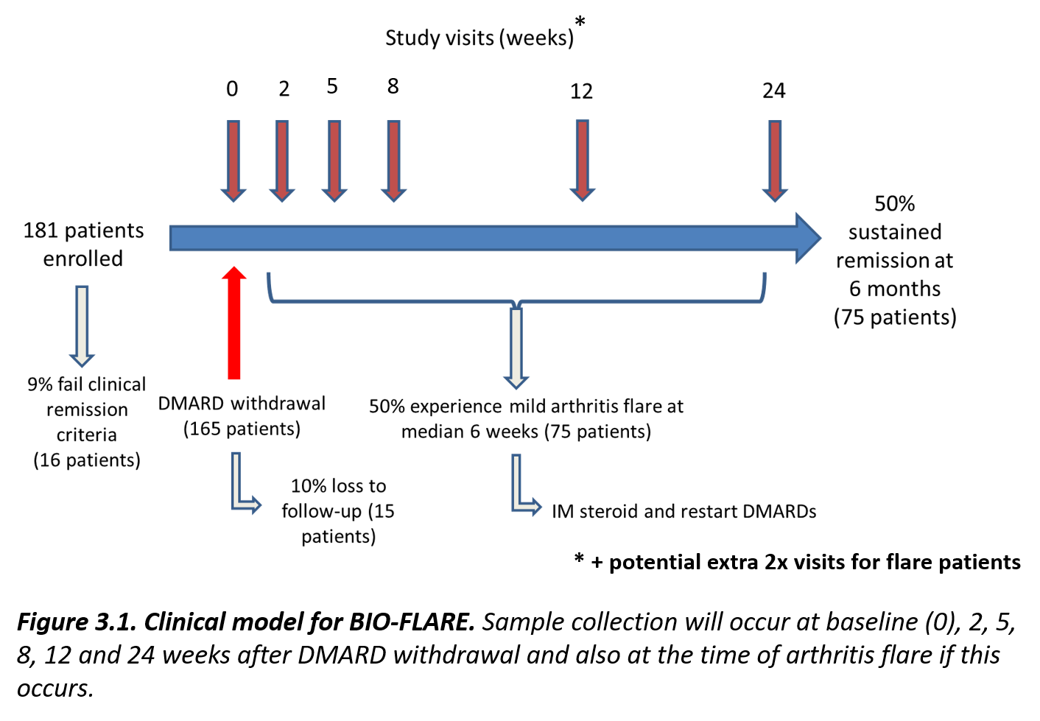

* At each study visit blood will be collected for clinical tests and research, along with urine and stool samples (see ***Table 3.1***). Stool samples will be sent directly to the analysis site (Oxford University) by the patients. Synovial biopsy samples will also be taken at baseline (optional) and after a confirmed flare. These will be collected and processed on a different day to the collection and processing of blood and urine - see the **BIO-FLARE - Synovial Biopsy Collection and Processing SOP Manual**.
* A **Blood and Urine Sample Record Log sheet** will be completed with the sample collection.
* The biological samples, along with the **Blood and Urine Sample Record Log sheet**, will be transported to the local hub University processing sites (see ***Figure 3.2***). A **Quality Control Worksheet** will be completed when processing the samples. Any deviations to the SOPs in this manual should be noted on this sheet under the ‘Notes’ section.
* After processing, samples will be stored at each processing site until transportation to the analysis sites (see ***Figure 3.2)***

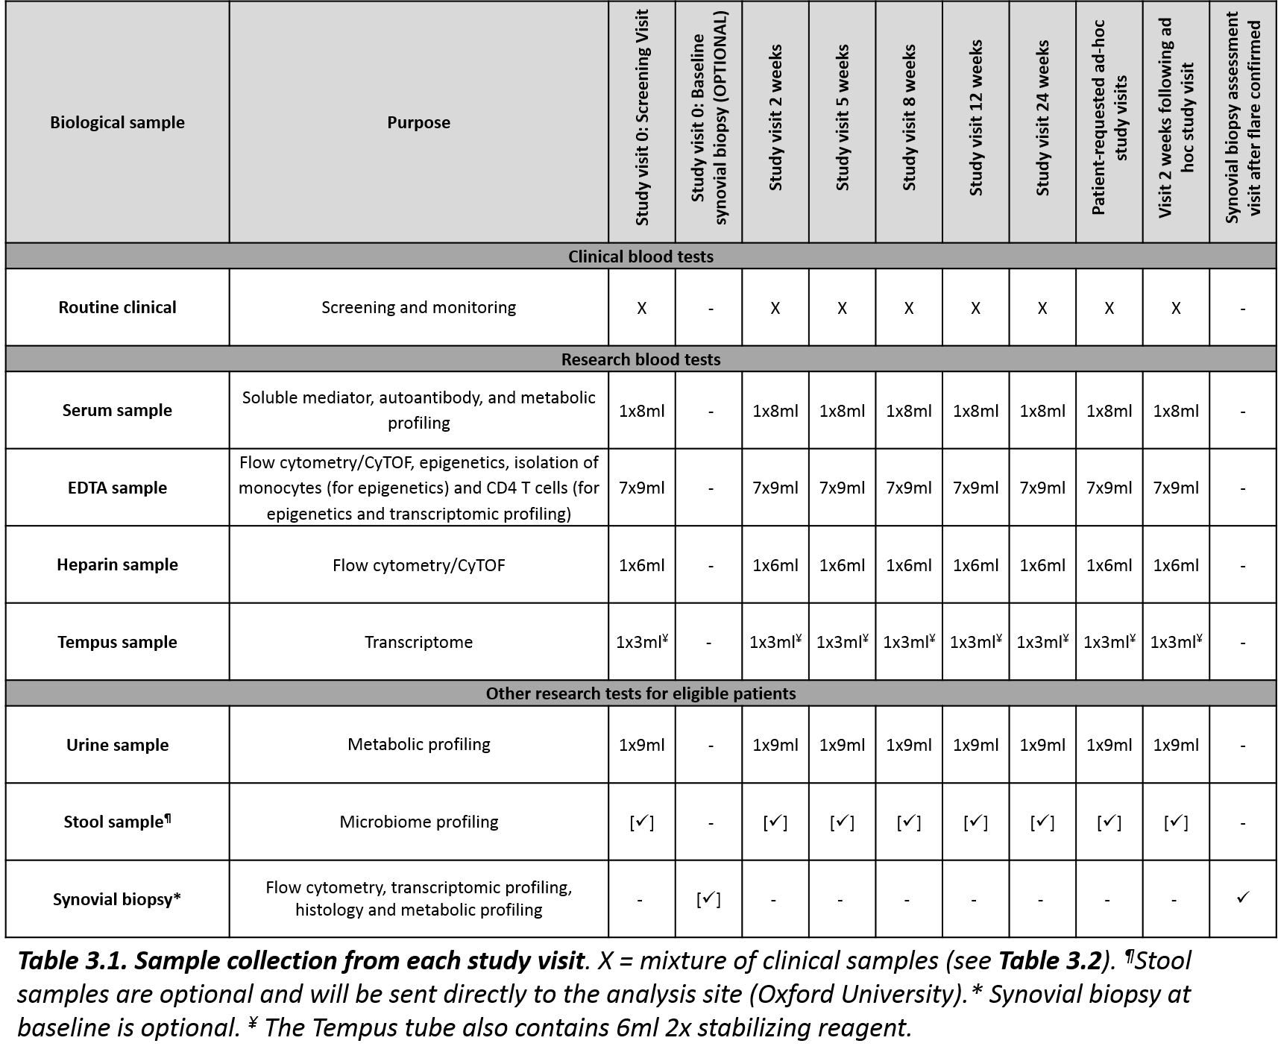

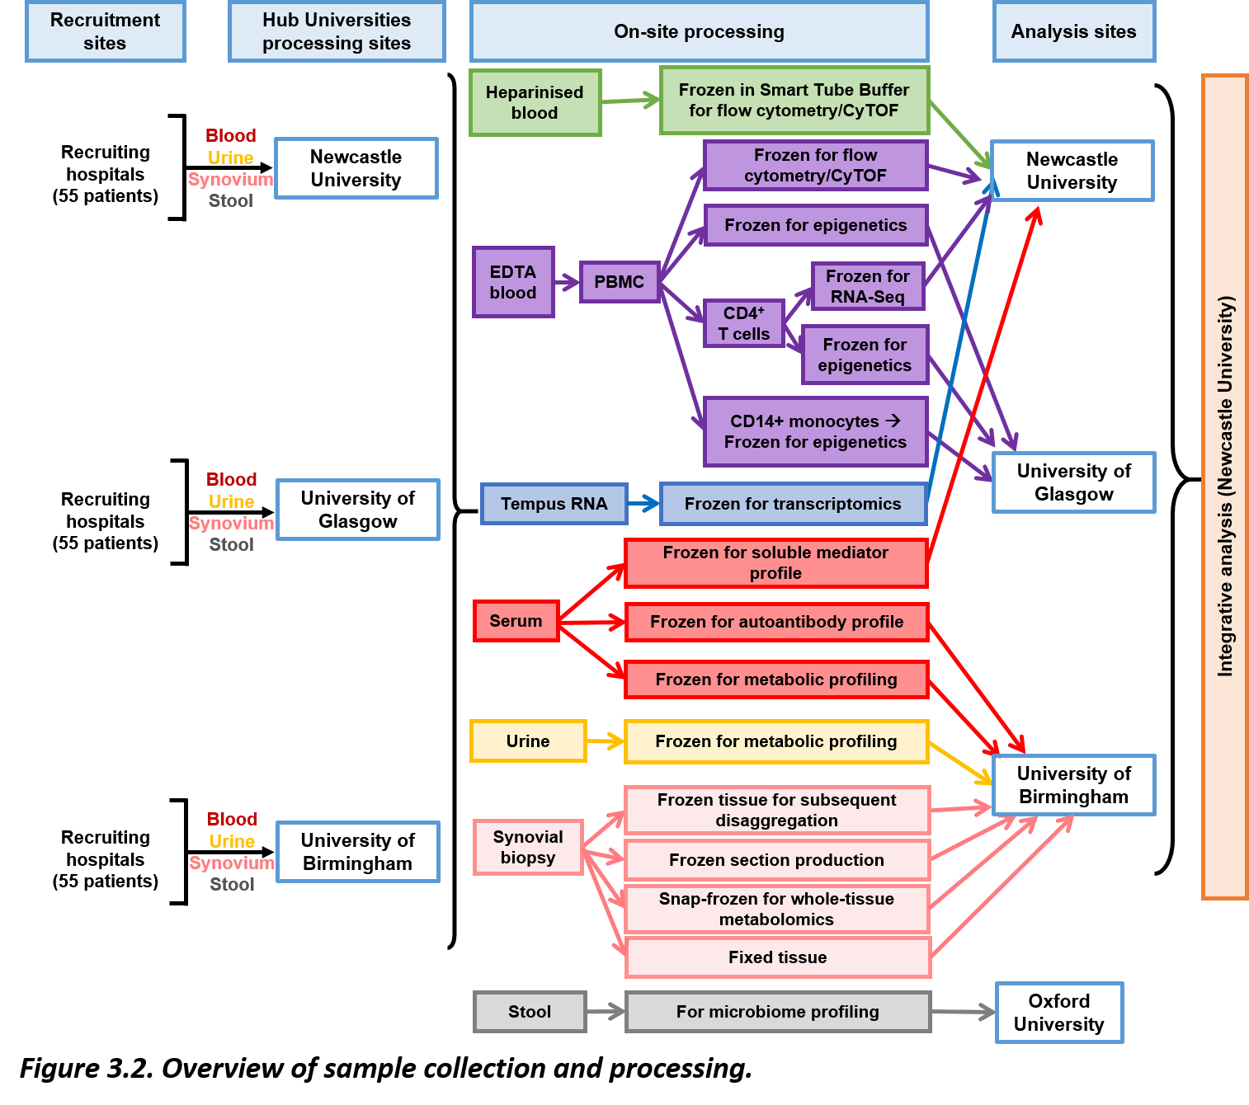

1. **BIO-FLARE** **cytokine reconstitution and storage for Smart Tube stimulation (BIO-FLARE SOP 006)**
   1. **Background**

* For use in the BIOlogical Factors that Limit sustAined Remission in rhEumatoid arthritis (BIO-FLARE) study.
* Cytokines, IL-6 and IFN-α2b, will be used to stimulate **heparin** blood to induce phosphorylation of a number of phospho-proteins as detailed in **BIO-FLARE Smart Tube stabilisation and storage of heparin blood SOP (BIO-FLARE SOP 007)**.
* In order to standardise the stimulation procedure across the three processing sites (Birmingham, Glasgow and Newcastle) the same lot of cytokines will be used at each site.
  + Each site will be provided with two vials of each lyophilised cytokine per year. This will be sent from Newcastle along with a BIO-FLARE cytokine reagent sheet for each vial.
  + Once reconstituted the cytokine is stable for 6 months when stored at -20°C.
  + Over the course of the study three different lots of each cytokine will be used as the lyophilised cytokine is only stable for a maximum of 12 months.
  + Lot to lot variation will be assessed and recorded by the Newcastle team.
  1. **Purpose**
* To provide a standardised method for the reconstitution and storage of IL-6 and IFN-α2b for the BIO-FLARE study.
  1. **Procedure**
     1. **Material and equipment**

See ***Appendix 1*** for ordering information

* Bovine serum albumin (BSA) (Sigma, cat no A9647-50G or similar)
* Sterile Dulbecco’s Phosphate Buffered Saline (DPBS) (Ca2+/Mg2+ free) (SLS, cat no LZBE17-512F or similar)
* 5x **sterile** 50ml centrifuge tubes (Greiner, cat no 227261 or similar)
* 0.2μm syringe filter (Fisher, cat no 10268401 or similar)
* 30ml syringe (SLS, cat no SYR6011 or similar)
* Sterile deionised water
* 200x **sterile** 0.5ml microcentrifuge tube (Starlab, cat no E1405-0600 or similar)
* 13x **sterile** 1.5ml microcentrifuge tubes (DNase and RNase free) (Starlab, cat no E1415-1500 or similar)
* Recombinant human IL-6, premium grade (Miltenyi Biotec, cat no 130-095-352).
  + This will be provided to each site by Newcastle
  + Each vial contains **10µg** of lyophilised IL-6. This should be reconstituted and stored as stated below prior to sample processing. Instructions on cytokine reconstitution will also be included with the cytokine shipment from Newcastle in the form of a **BIO-FLARE IL-6 reagent sheet**.
* Recombinant human IFN-α2b, research grade (Miltenyi Biotec, cat no 130-093-875).
  + This will be provided to each site by Newcastle
  + Each vial contains **20µg** of lyophilised IFN-α2b. This should be reconstituted and stored as stated below prior to sample processing. Instructions on cytokine reconstitution will also be included with the cytokine shipment from Newcastle in the form of a **BIO-FLARE IFN-α2 reagent sheet**.

*Sundry items*

* Solvent resistant permanent marker pen
* **BIO-FLARE** **IL-6 reagent sheet** (see ***Appendix 2***) – provided with the cytokine shipment
* **BIO-FLARE IFN-α2 reagent sheet** (see ***Appendix 3***) – provided with the cytokine shipment
* Pipette gun and 25ml, 10ml and 5ml stripettes
* p1000 and p200 pipettes and RNase, DNase, pyrogen-free filter pipette tips
* Balance
* Microcentrifuge
* Class II microbiological safety cabinet
* Vortex
* -20oC freezer
  + 1. **Protocol**

***Notes***

* The lyophilised cytokine should be stored at -20°C and is stable for 12 months.
* Once reconstituted the cytokine is stable for 6 months when stored at -20°C.
* The cytokines should be reconstituted and stored prior to use in the **BIO-FLARE Smart Tube stabilisation and storage of heparin blood SOP (BIO-FLARE SOP 007)**.
* **Upon reconstitution of each cytokine vial a BIO-FLARE IL-6 or IFN-α2 reagent sheet (**see ***Appendix 2 and 3, respectively*) should be completed by the person(s) reconstituting the cytokines**.

***Preparation of sterile PBS + 0.1% BSA***

* Make this fresh every time you reconstitute a new vial of cytokine
  1. Weight out 0.25g BSA and add to 25ml PBS in a 50ml centrifuge tube to make a 1% BSA solution.
  2. Gently mix or vortex to fully dissolve the BSA.
  3. Make a 10x dilution by pipetting 2.5ml of 1% BSA solution into a new 50ml centrifuge tube and adding 22.5ml PBS. Mix thoroughly. This is **PBS + 0.1% BSA**.
  4. In a class II microbiological safety cabinet, sterilise the solution by drawing the PBS + 0.1% BSA into a 30ml syringe, attach a 0.2μm filter to the syringe and gently filter the PBS + 0.1% BSA into a sterile 50ml centrifuge tube.

***Reconstitution and storage of IL-6***

1. Bring the vial to room temperature.
2. Spin the vial containing **10μg of lyophilised IL-6** at maximum speed in a microcentrifuge for 30 seconds.
3. In a class II microbiological safety cabinet, add **100μl sterile deionised water** into the vial (to give **100μg/ml primary stock**).
4. Mix carefully by gently pipetting up and down.
5. Cap the vial and spin at maximum speed in a microcentrifuge for a few seconds.
6. Dilute the **100μg/ml primary stock** to **1μg/ml master stock** in a class II microbiological safety cabinet:
   1. Add 8.9ml sterile PBS + 0.1% BSA to a 50ml centrifuge tube
   2. Transfer the 100μl of 100μg/ml primary stock to the tube containing the 8.9ml sterile PBS + 0.1% BSA
   3. Add 1ml sterile PBS + 0.1% BSA to the vial which originally contained the IL-6 and pipette up and down to wash the tube
   4. Transfer this 1ml wash to the 50ml centrifuge tube containing the diluted IL-6 – this is the **1μg/ml master stock**.
7. Prepare **100 x 20μl aliquots** of this **1μg/ml IL-6 master stock** in sterile 0.5ml microcentrifuge tubes labelled “IL-6_n”, where n is the BIO-FLARE batch number. The remaining cytokine solution can be stored as 8 x 1ml aliquots and used for other work.

**N.B.** Assign sequential batch numbers for each vial of IL-6 reconstituted, i.e. the first vial will be batch number 1, the second vial will be batch number 2, etc.

1. Store aliquots at -20°C and fill in the **BIO-FLARE IL-6 reagent sheet**.

**N.B. 1.** These are **single-use** aliquots - they should not be freeze-thawed

**N.B. 2.** These need to be diluted further on the day of the experiment before use - see **BIO-FLARE Smart Tube stabilisation and storage of heparin blood SOP (BIO-FLARE SOP 007)**.

***Reconstitution and storage of IFN-α2b***

1. Bring the vial to room temperature.
2. Spin the vial containing **20μg of lyophilised IFN-α2b** at maximum speed in a microcentrifuge for 30 seconds.
3. In a class II microbiological safety cabinet, add **200μl sterile deionised water** into the vial (to give **100μg/ml primary stock**).
4. Mix carefully by gently pipetting up and down.
5. Cap the vial and spin at maximum speed in a microcentrifuge for a few seconds.
6. Dilute the **100μg/ml primary stock** to **2.5μg/ml working stock** in a class II microbiological safety cabinet:
7. Add 6.8ml sterile PBS + 0.1% BSA to a 50ml centrifuge tube
8. Transfer the 200μl of 100μg/ml primary stock to the tube containing the 6.8ml sterile PBS + 0.1% BSA
9. Add 1ml sterile PBS + 0.1% BSA to the vial which originally contained the IFN-α and pipette up and down to wash the tube
10. Transfer this 1ml wash to the 50ml centrifuge tube containing the diluted IFN-α – this is the **2.5μg/ml working stock**.
11. Prepare **100 x 30μl** aliquots of this **2.5μg/ml IFN-α2b working stock solution** in sterile 0.5ml microcentrifuge tubes labelled “IFN-α_n”, where n is the BIO-FLARE batch number. The remaining cytokine solution can be stored as 5 x 1ml aliquots and used for other work.

**N.B.** Assign sequential batch numbers for each vial of IFN-α2b reconstituted, i.e. the first vial will be batch number 1, the second vial will be batch number 2, etc.

1. Store aliquots at -20°C and fill in the **BIO-FLARE IFN-α2b reagent sheet**.

**N.B.** These are **single-use** working stock aliquots - they should not be freeze-thawed.

1. **BIO-FLARE Smart Tube stabilisation and storage of heparin blood SOP (BIO-FLARE SOP 007)**
   1. **Background**

* For use in the BIOlogical Factors that Limit sustAined Remission in rhEumatoid arthritis (BIO-FLARE) study.
* Blood samples will be collected and transported to the University processing site according to according to the SOPs in the **BIO-FLARE – Blood and Urine Sample Collection SOP Manual**.
* These biological samples must be processed on the same day they are collected.
* Received blood samples will be tracked using the Laboratory Information Management System (LIMS) according to **BIO-FLARE** **Titian Mosaic Laboratory Inventory Management System Manual**.
* **Heparin** blood will be left unstimulated (basal) or stimulated with different stimuli (IL-6 alone and IFN-α alone) to induce phosphorylation of a number of phospho-proteins.
  + - Unstimulated whole blood will be prepared for storage at -80°C with the automated Smart Tube Base Station and Smart Tubes.
    - Stimulated whole blood will be prepared for storage at -80°C by manual means using Smart Tube Proteomic Stabiliser buffer
  1. **Purpose**
* To provide a standardised method for the stabilisation and storage of **heparin** blood, in order to guarantee biological samples of high quality for the BIO-FLARE study.
  1. **Procedure**
     1. **Material and equipment**

See ***Appendix 1*** for ordering information and numbers needed per patient visit

*For automated processing*

* Programming Station for Smart Tube Base Station (Smart Tube, cat no PROGRAM1P)
* Smart Tube Base Station (Smart Tube, cat no PBS05)
* 2x Smart Tubes (Smart Tube, cat no MTS1P)
* Suitable rack to hold tubes
* Smart Tube storage box - Corning 10x5 rack (SLS, cat no 431355)

*For manual processing*

* 2x 30ml sterile polystyrene universal tube (StarLab, cat no E14123010 or similar)
* Recombinant human IL-6, premium grade (Miltenyi Biotec, cat no 130-095-352).
  + This should be reconstituted to **1µg/ml master stock** and stored at -20°C according to **BIO-FLARE cytokine reconstitution and storage for Smart Tube stimulation (BIO-FLARE SOP 006)**
* Recombinant human IFN-α2b, research grade (Miltenyi Biotec, cat no 130-093-875).
  + This should be reconstituted to **2.5µg/ml working stock** and stored at -20°C according to **BIO-FLARE cytokine reconstitution and storage for Smart Tube stimulation (BIO-FLARE SOP 006)**
* Dulbecco’s Phosphate Buffered Saline (DPBS) (Ca2+/Mg2+ free) (SLS, cat no LZBE17-512F or similar)
* 1x **sterile** 0.5ml microcentrifuge tube (Starlab, cat no E1405-0600 or similar)
* Proteomic Stabilizer Buffer (Smart Tube, cat no PROT1-1L)
* 2x Cryo.s 5ml tubes (**red caps**) (Greiner, cat no 124273)
* 2x Cryo.s 5ml tubes (**blue caps**) (Greiner, cat no 124274)
* 1x Cryo rack for 48 Cryo.s tubes (Greiner, cat no 803270)

*Sundry items*

* Solvent resistant permanent marker pen
* **BIO-FLARE Summary Sample sheet** (see ***Appendix 4***)
* **Smart Tube Quality Control Worksheet** (see ***Appendix 5)***
* Smart Tube Barcode sheet containing 1D barcode labels (see ***Appendix 6***)
* Ice bucket and ice
* 37oC water bath. **Check the temperature with a thermometer**
* Stopwatch
* Pipette gun and 5ml stripettes
* p1000, p200 and p20 pipettes and RNase, DNase, pyrogen-free filter pipette tips
* Vortex
* -80oC freezer
  + 1. **Protocol**

***Notes***

* **Heparin** blood will be used for this process.
* Samples should be kept at room temperature until processing and should be processed as soon as possible. **Do not** leave these samples to be processed last.
* **Upon receipt the BIO-FLARE Summary Sample sheet (**see ***Appendix 4*) should be completed by the person(s) processing the sample and the barcoded blood sample tube should be scanned into the LIMS** (see **BIO-FLARE** **Titian Mosaic Laboratory Inventory Management System Manual**).

***Stabilisation and freezing of heparin blood using Smart Tubes and the Smart Tube Base Station (automated)***

* This processing protocol will generate 2 aliquots of stabilised untreated/unstimulated (basal) heparin blood in Smart Tubes.
* The Smart Tubes containing the samples will be barcoded, scanned into the LIMS and stored at -80oC according to the **BIO-FLARE** **Titian Mosaic Laboratory Inventory Management System Manual**.

1. ***Programming the automated Base Station***
   * **Do this in advance of the study**.
   * **This only needs to be done once if the Base Station is not used for anything else.**
   * Please type exactly as specified. For example: you must type '001' **NOT** '1', if that is specified below.

***Programming Station***



1. Ensure the Programming Station is off at the plug.
2. Plug the Programming USB Key into the Programming Station.
3. Turn on the Programming Station by the plug.
4. Type '**001**' into the Programming Station for the numerical ID of the protocol.
5. Press '**1**' to choose '1) Standard stim' for the profile type.
6. Type '**00**' hours for the stimulation duration.
7. Type '**15**' min for the stimulation duration.
8. Press '**1**' to choose '1) Yes' for rotation.
9. Type '**03**' minutes for the interval between rotations.
10. Type '**60**' seconds for the duration of rotation.
11. Press '**1**' to choose '1) Standard' for the rotation speed.
12. Type '**10**' minutes for the stabiliser reaction time.
13. The data input is now completed. Press '**Enter**' to advance through the programme parameters and please check that they are correct.
14. You will now be told that the programme is being uploaded onto the Programming USB Key. Leave the key in place until you are prompted that it is OK to remove it from the Programming Station.
15. Remove the Programming USB Key from the Programming Station, then turn off the Programming Station by the plug.

***Automated Base Station***



1. Ensure the Base Station is off - at both the back of the Base Station and at the plug.
2. Place the Programming USB Key into the receiver port at the back of the base station. Ensure it is properly seated.
3. Turn on the Base Station - first at the plug and then via the switch at the back of the Base Station.
4. The Base Station LCD display will report that it is starting up and then that it is uploading '**Programme 001**' from the Programming USB Key.
5. Leave the key in place in the Base Station until the LCD display reports that it is OK to remove it.
6. Remove the Programming USB Key from the Base Station. Turn off the Base Station via the switch on the back of the unit, then at the plug. Leave the Base Station for at least one minute before turning it on again.
7. When you turn on the Base Station, it should now report that '**Programme 001**' is being loaded into memory. Allow the Base Station time to ready itself. The **green button** will illuminate and start blinking when it is ready.
8. It is OK to turn off the Base Station at this ready phase. In normal circumstances, you would press the red button once an experiment run has completed and wait for the machine to report it is OK to switch off. Do not switch off the machine whilst it is performing a functional routine.
9. ***Preparing unstimulated whole blood for storage at -80°C***
10. Turn on the automated Base Station: first at the plug, then at the back of the base station.
11. The Base Station should say it is loading '**Programme 001**' into memory and the station will then adjust to the target temperature. This may take anywhere from a minute to half an hour depending on the temperature of the room, so turn on the unit well in advance.
12. The **green button** will blink when the Base Station is ready.
13. Take two Smart Tubes and record the lot number on the **Smart Tube Quality Control Worksheet** (see ***Appendix 5***).
14. Twist off the white caps from each Smart Tube and using filter tips pipette 1ml of whole blood into each tube. Pipette the blood slowly, in a controlled way down the wall of the Smart Tube, taking care not to damage the inner ampoule of Proteomic Stabiliser. Replace the white caps onto the Smart Tubes.
15. Slide the two, filled, Smart Tubes into the receiver slots in the Base Station. The white caps should be facing towards you. Twist each tube until it locks into the Base Station: the hexagonal bottom of the tube slots into a hexagonal receiver pad inside the Base Station.
16. When the **green button** is illuminated and blinking, the machine is ready. Press the **green button** to start the programme.
17. Record the time the Base Station programme was started on the **Smart Tube Quality Control Worksheet**.
18. When the programme is complete and the samples are ready for storage, the **red button** will illuminate. The LCD display will also report that the samples are being held at 4°C.
19. Remove the Smart Tubes from the Base Station and place them on ice.
20. Press the **red button** to shut down the machine. Once shut down turn off the power at the back of the Base Station and then at the plug.
21. Attach a “ST” barcode label to each tube (see ***Appendix 6***) and clearly write the date on each tube.
22. Each Smart Tube now has a unique 1D barcode and should be scanned into the LIMS prior to being stored at -80oC in the correct positions of an appropriate storage box as indicated by the LIMS - see **BIO-FLARE** **Titian Mosaic Laboratory Inventory Management System Manual**). To help with the correct placement on tubes in already existing storage boxes in the freezer a **LIMS Tube Location sheet** (see ***Appendix 7***) may be filled out.
23. Immediately transfer the Smart Tubes to -80°C storage and record the time of freezing on the **Smart Tube** **Quality Control Worksheet**.

***Stimulation, stabilisation and freezing of heparin blood using Smart Tubes and*** ***Proteomic Stabilizer Buffer (manual)***

* This processing protocol will generate stabilised heparin blood which has been stimulated with two different stimulation conditions:
  + 2 aliquots stimulated with **0.5ng/ml IL-6**, stored in 5ml Cryo.s tubes (**red caps**).
  + 2 aliquots stimulated with **25ng/ml IFN-α2b**, stored in 5ml Cryo.s tubes (**blue caps**).
* The Proteomic Stabilizer Buffer should be at room temperature.

1. Check the temperature of the water bath with a thermometer to verify it is at 37°C. Record this has been done on the **Smart Tube** **Quality Control Worksheet** (see ***Appendix 5)***.
2. For the IL-6 stimulated condition:
   1. Remove 1x aliquot of 20µl of **1µg/ml master stock IL-6** from the -20oC freezer and thaw at room temperature. You will need 10µl per patient sample.
   2. Record the BIO-FLARE batch number of IL-6 on the **Smart Tube** **Quality Control Worksheet**.
   3. Spin the tube containing the cytokine at maximum speed in a microcentrifuge for 30 seconds.
   4. Pipette **10μl of this 1μg/ml IL-6 solution** into a sterile 0.5ml microcentrifuge tube.

**N.B.** Dispose of the remaining aliquot of master stock at this point, to avoid any possibility of further confusion.

* 1. Add **190μl sterile PBS** and pipette up and down gently to mix. to prepare a **200μl working stock** aliquot, at a concentration of **50ng/ml**. This is the working stock that you will use for the stimulation of **heparin** blood. Record that this working stock has been prepared in the **Smart Tube** **Quality Control Worksheet**.

1. For the IFN-α2b stimulation remove 1x aliquot of 30µl of **2.5µg/ml working stock IFN-α2b** from the -20oC freezer and thaw at room temperature. You will need 20µl per patient sample. Record the BIO-FLARE batch number of IFN-α2b the **Smart Tube** **Quality Control Worksheet**.
2. Transfer **2ml** **heparin** blood to the 2 separate 30ml universal tubes.
3. To one tube labelled “IL-6” add **20µl of 50ng/ml IL-6 working stock** (prepared as per step 2) to the blood, producing a final concentration of **0.5ng/ml IL-6**.
4. Briefly vortex the tube and immediately place the tube in the 37°C water bath for **15 minutes**. **Start the stopwatch**.
5. Record the **experiment start time** on the **Smart Tube** **Quality Control Worksheet**.

**N.B.** The duration of incubation at 37oC should be consistent across samples in the study.

1. At 1 minute on the stopwatch, add **20µl of 2.5µg/ml IFN-α2b** (prepared as per step 3) to the blood in the second tube labelled “IFN-α”, producing a final concentration of **25ng/ml IFN-α2b**.
2. Briefly vortex the tube and immediately place the tube in the 37°C water bath for **15 minutes**.
3. **At 15 min on the stopwatch**, add **2.8ml Smart Tube Proteomic Stabiliser buffer** to the first tube containing the IL-6 stimulus and mix by vortexing for 5 seconds.
4. **At 16 min on the stopwatch**, add **2.8ml Smart Tube Proteomic Stabiliser buffer** to the second tube containing X and mix by vortexing for 5 seconds.
5. Place both 30ml universal tubes containing the stabilised blood in a suitable rack on the benchtop and **incubate them at room temperature** until the **stopwatch reads 26 minutes** (i.e. incubate for **10 minutes**).

**N.B.** The duration of incubation at room temperature should be consistent across samples in the study.

1. Equally divide the contents of each 30ml universal into two 5ml Cryo.s tubes per stimulation as follows:
   1. 2x aliquots of 2.4ml stabilised whole blood stimulated with IL-6 (**red caps**)
   2. 2.4ml stabilised whole blood stimulated with IFN-α2b (**blue caps**)
2. The sample is now stabilised. Clearly write the date on each tube and attach a barcode label (see ***Appendix 6***) to each tube as follows:

* “IL” barcode on each IL-6 stimulated tube
* “IF” barcode on each IFN-α2b stimulated tube

1. Place the tubes on ice.
2. Record the **finish time of the experiment** on the **Smart Tube Quality Control Worksheet**.
3. Each tube now has a unique 1D barcode and should be scanned into the LIMS prior to being stored at -80oC in the correct positions of an appropriate storage box as indicated by the LIMS - see **BIO-FLARE** **Titian Mosaic Laboratory Inventory Management System Manual**). To help with the correct placement on tubes in already existing storage boxes in the freezer a **LIMS Tube Location sheet** (see ***Appendix 7***) may be filled out.
4. Immediately transfer the tubes to -80°C storage and record the time of freezing on the **Smart Tube** **Quality Control Worksheet**.
5. **BIO-FLARE serum and urine sample separation and storage SOP (BIO-FLARE SOP 008)**
   1. **Background**

* For use in the BIOlogical Factors that Limit sustAined Remission in rhEumatoid arthritis (BIO-FLARE) study.
* Blood and urine samples will be collected and transported to the University processing site according to according to the SOPs in the **BIO-FLARE – Blood and Urine Sample Collection SOP Manual**.
* These biological samples must be processed on the same day they are collected.
* Received blood and urine samples, as well as processed stored samples will be tracked using the Laboratory Information Management System (LIMS) according to the **BIO-FLARE** **Titian Mosaic Laboratory Inventory Management System Manual**.
  1. **Purpose**
* To guarantee a high standard of the separation and storage of **SERUM** and **URINE** samples for the BIO-FLARE study.
  1. **Procedure**
     1. **Material and equipment**

See ***Appendix 1*** for ordering information and numbers needed per patient visit.

* 1.4ml FluidX tubes (6x **red caps** (**SERUM**) and 6x **yellow caps** (**URINE**)) and suitable rack to hold tubes
* FluidX storage box (8x12)
* 0.2μm syringe filter (Fisher, cat no 10268401 or similar)
* 10ml syringe (SLS, cat no SYR6206 or similar)
* 30ml sterile polystyrene universal tube (StarLab, cat no E14123010 or similar)

*Sundry items*

* Solvent resistant permanent marker pen
* **BIO-FLARE Summary Sample sheet** (see ***Appendix 4***)
* **Quality Control Worksheet** (see ***Appendix 8****)*
* Centrifuge with swing-out or 45 degree fixed angle rotor capable of spinning at 1800g
* Class II microbiological safety cabinet
* p1000 pipette and sterile, RNase, DNase, pyrogen-free pipette tips
* -80oC freezer
  + 1. **Protocol**

***Notes***

* For certain parameters like cytokines, hormones or vitamins, samples have to be transported to the lab immediately after blood collection and fractionated. As a guideline **ideally no longer than 60 minutes after collection**. Hence, the specimen should be separated first when arriving at the lab.
* **Upon receipt the BIO-FLARE Summary Sample sheet (**see ***Appendix 4*) should be completed by the person(s) processing the sample and the barcoded blood and urine sample tubes should be scanned into the LIMS** (see **BIO-FLARE** **Titian Mosaic Laboratory Inventory Management System Manual**).
* **The date and time of sample receipt and the name of the person who received the samples should be recorded on the Quality Control Worksheet (**see ***Appendix 8*).** In addition, the start time of centrifugation should be recorded so the person using the specimen is aware of the conditions. In the case of a late sample arrival it should be separated, and the relevant information recorded on the Quality Control Worksheet under the ‘Notes’ section.
* After centrifugation/separation the samples should be aliquoted in a class II microbiological safety cabinet to maintain sterility and stored in the freezer at the relevant temperature.
* Both sample types (serum and urine) can be centrifuged at the same time in parallel.

***Serum (red top tube)***

1. Clearly write the date on 6x 1.4ml FluidX tubes (**red caps**) using a solvent resistant permanent marker pen.
2. The serum tube must be mixed and left for 30 minutes minimum **BUT** no longer than 1 hour to allow the blood to clot at room temperature.
3. Spin the serum tube at **1800g**for **12 minutes** at **room temperature**, **brake on**.

**N.B.** Spin the urine tube at the same time as the serum tube.

1. Serum should then be split equally in 6 aliquots of 0.5ml in 1.4ml FluidX tubes (**red caps**) using a p1000 pipette. Record the number of aliquots on the **Quality Control Worksheet**.

**N.B.** If there is not enough serum to store 6 aliquots of 0.5ml, store as many 0.5ml aliquots as possible.

1. Each FluidX tube has a unique 2D barcode and should be scanned into the LIMS prior to being stored at -80oC in the correct positions of a FluidX storage box (8x12) as indicated by the LIMS - see **BIO-FLARE** **Titian Mosaic Laboratory Inventory Management System Manual**. To help with the correct placement on tubes in already existing storage boxes in the freezer a **LIMS Tube Location sheet** (see ***Appendix 7***) may be filled out.
2. Immediately transfer the tubes to -80°C storage and record the time of freezing on the **Quality Control Worksheet**.

***Urine (yellow top tube)***

1. Clearly write the date 6x 1.4ml FluidX tubes (**yellow caps**) using a solvent resistant permanent marker pen.
2. Spin the urine tube containing urine directly in a centrifuge at **1800g**for **12 minutes**, **brake on** at **room temperature**.

**N.B.** Spin the serum tube at the same time as the urine tube.

1. Pour the urine into a 30ml universal tube
2. Draw the urine into a 10ml syringe
3. Attach a **0.2μm filter** to the syringe
4. Gently filter the urine into a sterile 30ml universal tube.
5. Urine should then be split equally in 6 aliquots of 0.9ml in 1.4ml FluidX tubes (**yellow caps**) using a p1000 pipette. Record the number of aliquots on the **Quality Control Worksheet**.

**N.B.** If there is not enough urine to store 6 aliquots of 1ml, store as many 1ml aliquots as possible.

1. Each FluidX tube has a unique 2D barcode and should be scanned into the LIMS prior to being stored at -80oC in the correct positions of a FluidX storage box (8x12) as indicated by the LIMS - see **BIO-FLARE** **Titian Mosaic Laboratory Inventory Management System Manual**. To help with the correct placement on tubes in already existing storage boxes in the freezer a **LIMS Tube Location sheet** (see ***Appendix 7***) may be filled out.
2. Immediately transfer the tubes to -80°C storage and record the time of freezing on the **Quality Control Worksheet**.
3. **BIO-FLARE Tempus Blood RNA tube storage** **SOP (BIO-FLARE SOP 009)**
   1. **Background**

* For use in the BIOlogical Factors that Limit sustAined Remission in rhEumatoid arthritis (BIO-FLARE) study.
* Blood and urine samples will be collected and transported to the University processing site according to according to the SOPs in the **BIO-FLARE – Blood and Urine Sample Collection SOP Manual**.
* These biological samples must be processed on the same day they are collected.
* Received blood samples will be tracked using the Laboratory Information Management System (LIMS) according to **BIO-FLARE** **Titian Mosaic Laboratory Inventory Management System Manual**.
  1. **Purpose**
* To detail the processing and storage of blood samples for RNA extraction using **TEMPUS** Blood RNA tubes for the BIO-FLARE study.
  1. **Procedure**
     1. **Material and equipment**

See ***Appendix 1*** for ordering information and numbers needed per patient visit.

* Storage box (7x7) (StarLab, cat no. A9627-4949)

*Sundry items*

* Solvent resistant permanent marker pen
* **Quality Control Worksheet** (see ***Appendix 10****)*
* Suitable rack to hold tubes at room temperature
* -80oC freezer
  + 1. **Protocol**

1. The **barcoded Tempus Blood RNA tube should be scanned into the LIMS** upon receipt at the processing site (see **BIO-FLARE** **Titian Mosaic Laboratory Inventory Management System Manual**). To help with the correct placement on tubes in already existing storage boxes in the freezer a **LIMS Tube Location sheet** (see ***Appendix 7***) may be filled out.
2. Clearly write the date on the Tempus Blood RNA tube using a solvent resistant permanent marker pen.
3. To standardise freezing, upon arrival at the processing site the samples should be maintained at room temperature (18-22°C) for **precisely 3 hours from blood collection** and then transferred to a -80°C freezer. Place it in the correct position in the Tempus Blood RNA storage box (7x7) indicated by the LIMS.
4. Record the time of freezing on the **Quality Control Worksheet**. Record any deviations from the 3 hour time point on the **Quality Control Worksheet** under the ‘Notes’ section.
5. **BIO-FLARE preparation and storage of peripheral blood mononuclear cells SOP (BIO-FLARE SOP 010)**
   1. **Background**

* For use in the BIOlogical Factors that Limit sustAined Remission in rhEumatoid arthritis (BIO-FLARE) study.
* Blood samples will be collected and transported to the University processing site according to according to the SOPs in the **BIO-FLARE – Blood and Urine Sample Collection SOP Manual**.
* These biological samples must be processed on the same day they are collected.
* Received blood samples will be tracked using the Laboratory Information Management System (LIMS) according to **BIO-FLARE** **Titian Mosaic Laboratory Inventory Management System Manual**.
* Peripheral blood mononuclear cells (PBMC) will be separated from **EDTA** blood and the resulting cells will be split –60% will be used for isolation of monocytes and CD4+ T cells and 40% will be cryopreserved in Bambanker (see ***Figure 8.1***).

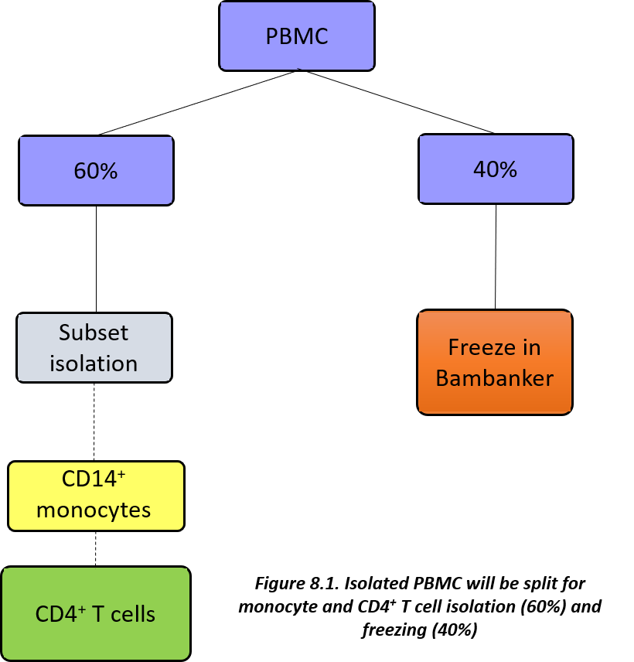

* 1. **Purpose**
* To provide a standardised method for PBMC separation and storage from **EDTA** blood, in order to guarantee biological samples of high quality for the BIO-FLARE study.
  1. **Procedure**
     1. **Material and equipment**

See ***Appendix 1*** for ordering information and numbers needed per patient visit.

* 6x **sterile, pre-capped** 2ml FluidX tubes (**orange caps**) and suitable rack to hold tubes
* FluidX storage box (6x8)
* 1x 1.4ml FluidX tube (**white cap**) and suitable rack to hold tubes
* FluidX storage box (8x12)
* 3x 50ml LeucoSep tubes (Greiner, cat no 227290)
* Lymphoprep (Alere, cat no 1114547)
* 3x sterile 50ml centrifuge tubes (Greiner, cat no 227261 or similar)
* Sterile Dulbecco’s Phosphate Buffered Saline (DPBS) (**Ca2+/Mg2+ free**) (SLS, cat no LZBE17-512F or similar) – **use cold**
* 2x 30ml sterile polystyrene universal tube (StarLab, cat no E14123010 or similar)
* Bambanker serum-free freezing medium (Fisher, cat no 13109155)

*Sundry items*

* Solvent resistant permanent marker pen
* **Quality Control Worksheet** (see ***Appendix 8)***
* Class II microbiological safety cabinet
* Suitable rack to hold tubes
* Pipette gun and sterile 25ml, 10ml, and 5ml stripettes
* Refrigerated centrifuge with swing-out or 45 degree fixed angle rotor capable of spinning at 800g
* Aspirator (optional)
* Ice bucket and ice
* p1000, p200 and p20 pipettes and sterile, RNase, DNase, pyrogen-free pipette tips
* -80oC freezer
* Liquid nitrogen freezer store
  + 1. **Protocol**

***Notes***

* PBMC will be isolated from **EDTA** blood.
* **Upon receipt barcoded blood sample tubes should be scanned into the LIMS** (see **BIO-FLARE** **Titian Mosaic Laboratory Inventory Management System Manual**).
* Samples should be kept at room temperature until processing and should be processed within a 1 hour window if possible.
* This procedure should be performed in a class II microbiological safety cabinet to maintain sterility.
* It is important to know what volume of blood is actually obtained as the tubes don’t always contain the volume written on the side of the tube.
* If possible an aspirator should be used to remove supernatants but as an alternative pour off the supernatants, taking care not to lose the cell pellet.
* Calcium is essential for certain cell adhesion molecules and signalling pathways to become active. Therefore, Dulbecco’s Phosphate Buffered Saline (DPBS) which is Ca2+/Mg2+ free should be used to reduce cell adhesion and cell activation during the PBMC isolation steps.
* After the separation centrifugation step (at 800g) keep the cells on ice between the centrifugation steps.
* After PBMC separation the cells will be split and 40% of the cells will be cryopreserved and 60% will be used for isolation of monocytes and CD4+ T cells.

***Preparation of LeucoSep tubes***

1. Warm up the Lymphoprep to room temperature, protected from light.

**N.B.** This step is especially important during winter as the Lymphoprep needs to be at 20-25°C.

1. Add 15ml Lymphoprep to each of 3x 50ml LeucoSep tubes.
2. Centrifuge the LeucoSep tubes at **1000g** for **30 seconds** at **room temperature**, **brake on**.
3. The Lymphoprep should now be located below the porous barrier and are ready for use.

**N.B.** The LeucoSep tubes are be prepared in advance and stored at room temperature, protected from the light. If this approach is used make sure the LeucoSep tube is warmed up to room temperature before use.

***Separation of PBMC using LeucoSep tubes***

1. Pre-cool PBS on ice
2. **If you haven’t already done so** centrifuge 3x 50ml prepared (Lymphoprep filled) LeucoSep tubes at **1000g** for **30 seconds** at **room temperature**, **brake on**. This will ensure that the Lymphoprep medium is below the porous barrier.
3. From the biological samples sent from the clinic select 7x **EDTA** tubes (~63ml blood) and invert the tubes to mix the blood.
4. Transfer the blood equally to the LeucoSep tubes using a 10ml stripette (each LeucoSep tube should contain ~20ml blood). **Record the actual volume of blood on the Quality Control Worksheet** (see ***Appendix 8).***

**N.B.** In order to balance the centrifuge the tubes must be equally filled.

1. Centrifuge the LeucoSep tubes at **800g** for **15 minutes** at **room temperature** with **NO BRAKE** (separation step).
2. After centrifugation the LeucoSep tubes will look similar to ***Figure 8.2***.

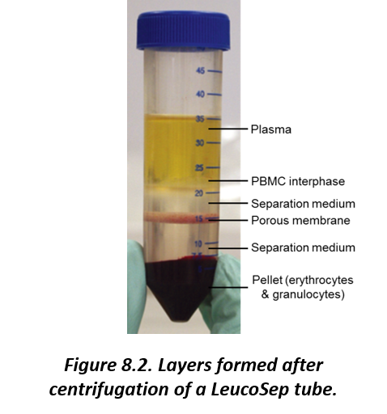

1. Collect the PBMC interphase containing PBMC and platelets (above the porous membrane) by pouring the contents of each LeucoSep tube directly into a sterile separate 50ml centrifuge tube (the barrier will prevent contamination and pouring off of the pellet).
2. Top-up the volume of each tube containing the PBMC to **50ml** with **cold PBS**.
3. Invert the tubes several times to mix.
4. Centrifuge at **600g** for **6 minutes**, **4°C**, **brake on** (density centrifugation medium wash to remove contaminating Lymphoprep medium, which is toxic to cells).
5. Aspirate or pour off the supernatant and loosen the cell pellet thoroughly by flicking the tube.
6. Resuspend the pellet from the tube 1 in **25ml** of **cold PBS**.
7. Pipette up and down to ensure all the cells are resuspended and then transfer the cell suspension to tube 2. Repeat this step, transferring all the cell suspension to tube 3.
8. Top-up the volume to 50ml with cold PBS (i.e. **add 25ml**).
9. Centrifuge at **300g** for **6 minutes**, **4°C**, **brake on** (platelet wash to reduce platelet contamination in PBMC).
10. Aspirate or pour off the supernatant and loosen the cell pellet thoroughly by flicking the tube. Resuspend the pellet in **40ml** of **cold PBS**.
11. **Count** the PBMC using an **appropriate counting method**, e.g. Burker or Neubauer counting chamber (see ***Appendix 9*** for example protocols). A **2x dilution** of the cells is recommended. Record the PBMC count on the **Quality Control Worksheet**.

**N.B.** For an accurate cell count a total of 25-100 cells should be counted in 1mm2 area. If less cells are counted use a lower dilution (neat) to count and if more cells are counted use a higher dilution.

1. Split the sample for further downstream processing as follows:
   * Transfer **24ml** PBMC (60%) to a sterile 30ml universal tube labelled “PBMC for cell isolation” for **cell subset isolation** (see **BIO-FLARE isolation of cell subsets (monocytes and CD4+ T cells) using the Miltenyi MACS system SOP (BIO-FLARE SOP 011)** using the Miltenyi MACS system. **Place on ice or store at 4°C until used**.
   * Keep the remaining **16ml** PBMC (40%) for **freezing** for epigenetic analysis and flow cytometry/CyTOF (see **Freezing and storage of PBMC** section below). Label the tube “PBMC for freezing”. **Place on ice or store at 4°C until used**.

***Freezing and storage of PBMC***

* **16ml PBMC (40%)** from **EDTA** blood (see **Separation of PBMC using LeucoSep tubes** section) will be frozen for epigenetic analysis and flow cytometry/CyTOF.
* The PBMC will be frozen in Bambanker serum-free freezing medium as follows (see ***Figure 8.3***):
  + **1x aliquot** of **1x105 cells** in **0.5ml Bambanker** in a **1.4ml FluidX tube (white cap)** for ATAC-seq
  + **Remaining cells** frozen in **6x aliquots** in **1ml Bambanker** in **2ml FluidX tubes (orange caps – labelled “PBMC”)** for EpiSwitch and flow cytometry/CyTOF.
* When using Bambanker there is no need for step-wise temperature reductions, therefore a CoolCell or Mr Frosty is not required.

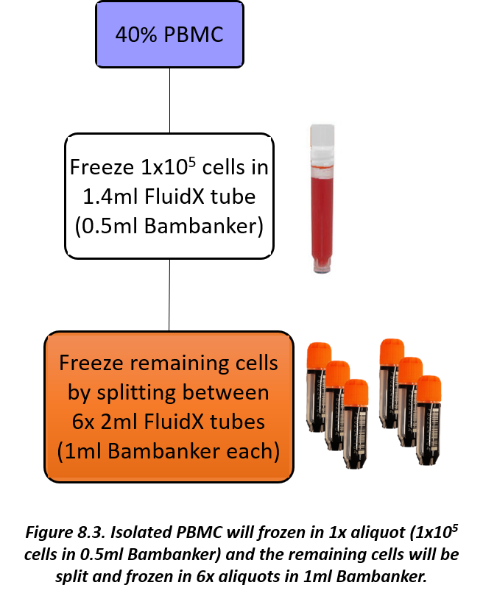

1. Clearly write the date on **1x 1.4ml FluidX tube (white cap)** and **6x 2ml FluidX tubes (orange caps)** using a solvent resistant permanent marker pen.
2. Write “**PBMC**” on the **6x 2ml FluidX tubes (orange caps)** to be used.
3. Based on the cell count calculate the volume of PBMC required to give 1x105 cells (record this on the **Quality Control Worksheet**) and transfer the calculated volume from the 16ml PBMC suspension to a sterile 30ml universal tube labelled “PBMC white”. These PBMC are for downstream ATAC-seq analysis and will be stored in 0.5ml Bambanker in a 1.4ml FluidX tube (**white caps**). The remaining PBMC from the 16ml PBMC suspension are for downstream epigenetic and flow cytometry/CyTOF analysis and will be stored in 6x 2ml FluidX tubes (**orange caps – labelled “PBMC”**) in 1ml Bambanker per tube.
4. Top-up both the 50ml centrifuge tube and 30ml universal tube containing the PBMC with cold PBS (i.e. **add 34ml** and **25ml**, respectively).

**N.B.** The **maximum volume** for the 30ml universal tubes is **25ml**.

1. Centrifuge PBMC at **400g** for **6 minutes**, **4°C, brake on**.
2. Aspirate or pour off the supernatant and loosen the cell pellet thoroughly by flicking the tube.
3. Resuspend the cells in Bambanker as follows:

* **1x105 PBMC** for **ATAC-seq**

1. Add 0.5 ml of Bambanker.
2. Transfer the 0.5ml resuspended cells to **1x 1.4ml FluidX tube (white cap).** Therefore, **1x105 PBMC/0.5ml/tube** will be stored.
   * **Remaining PBMC** for **EpiSwitch and flow cytometry/CyTOF**
     1. Add 6ml of Bambanker.
     2. Transfer 1ml resuspended cells to **6x 2ml FluidX tubes (orange caps – labelled “PBMC”)**.
     3. Based on the cell count, taking into account the removal of 1x105 PBMC for the ATAC-seq aliquot, calculate the number of PBMC in each 2ml FluidX tube and record this on the **Quality Control Worksheet**.
3. Each FluidX tube has a unique 2D barcode and should be scanned into the LIMS prior to being stored at -80oC in the correct positions of FluidX storage boxes (8x12 for 1.4ml FluidX tubes and 6x8 for 2ml FluidX tubes) as indicated by the LIMS - see **BIO-FLARE** **Titian Mosaic Laboratory Inventory Management System Manual**. To help with the correct placement on tubes in already existing storage boxes in the freezer a **LIMS Tube Location sheet** (see ***Appendix 7***) may be filled out.
4. Immediately transfer the tubes to -80°C storage and record the time of freezing on the **Quality Control Worksheet**.
5. Transfer the FluidX storage boxes to the gas phase of liquid nitrogen for long term storage within 2-3 days and **update the storage location on LIMS** - see **BIO-FLARE** **Titian Mosaic Laboratory Inventory Management System Manual**.

**N.B.** Be careful that the frozen cell samples do not thaw. Transfer the cell samples on dry ice.

1. **BIO-FLARE isolation of cell subsets (monocytes and CD4+ T cells) using the Miltenyi MACS system SOP (BIO-FLARE SOP 011)**
   1. **Background**

* For use in the BIOlogical Factors that Limit sustAined Remission in rhEumatoid arthritis (BIO-FLARE) study.
* Peripheral blood mononuclear cells (PBMC) are purified from **EDTA** blood according to **BIO-FLARE preparation and storage of peripheral blood mononuclear cells SOP (BIO-FLARE SOP 010)**.
* The Miltenyi MACS system will be used to positively isolate CD14-expressing monocytes and CD4-expressing T cells in sequential order (see ***Figure 9.1***).
* The purity of the cells will be analysed using flow cytometry using a 2x105 cell aliquot.
* The purified monocytes will be cryopreserved in Bambanker serum-free medium:
  + **1x aliquot of 1x105 monocytes** in **0.5ml Bambanker** for ATAC-seq
  + **1x aliquot of monocytes** in **1ml Bambanker** for EpiSwitch
* The purified CD4+ T cells will be split – 50% will be cryopreserved in Bambanker serum-free medium and 50% will be lysed in QIAzol Lysis Reagent:
  + **1x aliquot of 1x105 CD4+ T cells** in **0.5ml Bambanker** for ATAC-seq
  + **1x aliquot of CD4+ T cells** in **1ml Bambanker** for EpiSwitch.
  + **1x aliquot of CD4+ T cells** in **700μl QIAzol Lysis Reagent** for subsequent RNA extraction.

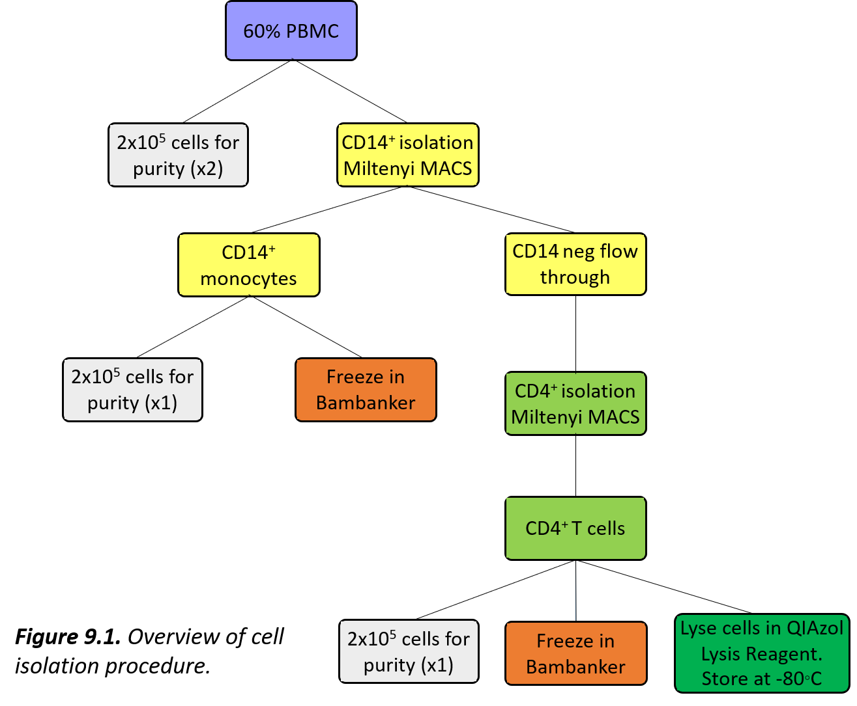

* 1. **Purpose**
* To provide a step-by-step method to efficiently separate human CD14+ monocytes and CD4+ T cells from peripheral blood mononuclear cells (PBMC) for cryopreservation and downstream RNA extraction.
  1. **Procedure**
     1. **Material and equipment**

See ***Appendix 1*** for ordering information and numbers needed per patient visit.

* 96 well v-bottom well plate (Greiner, cat no 651101 or similar)
* 2x **sterile, pre-capped** 2ml FluidX tubes (**orange caps**) and suitable rack to hold tubes
* 2x FluidX storage box (6x8)
* 1x 1.4ml FluidX tube (**amber caps**) and suitable rack to hold tubes
* 1x 1.4ml FluidX tube (**blue caps**) and suitable rack to hold tubes
* 1x 1.4ml FluidX tube (**green caps**) and suitable rack to hold tubes
* 2x FluidX storage boxes (8x12)
* Sterile Dulbecco’s Phosphate Buffered Saline (DPBS) (**Ca2+/Mg2+ free**) (SLS, cat no LZBE17-512F or similar)
* Foetal calf serum (FCS) (Sigma, cat no F7524 or similar)
* Endotoxin free 0.5M EDTA (Sigma, cat no E7889-100ML or similar)
* 0.22 µm vacuum PES filter unit (Fisher, cat no 10229090 or similar)
* **MACS Buffer** (DPBS + 0.5% FCS + 2mM EDTA):
  + 500 ml DPBS (**Ca2+/Mg2+ free**)
  + 2.5ml FCS
  + 2 ml endotoxin free 0.5M EDTA

**Important: Filter the solution through a 0.2 µm vacuum filter unit and cool on ice before use. Store at 4°C for 2 months.**

* Human CD14 MicroBeads (Miltenyi Biotec, cat no 130-050-201)
* Human CD4 MicroBeads (Miltenyi Biotec, cat no 130-045-101)
* 2x LS positive selection columns (Miltenyi Biotec, cat no 130-042-401) – **pre-cool at 4°C for 15 minutes before use**.
* MidiMACS Separator (Miltenyi Biotec, cat no 130-042-302) with MACS MultiStand (Miltenyi Biotec, cat no 130-042-303) or other suitable Miltenyi magnet compatible with LS positive selection columns, e.g. QuadroMACS (Miltenyi Biotec, cat no 130-091-051) or VarioMACS (Miltenyi Biotec, cat no 130-090-282)
* 7x sterile 30ml polystyrene universal tube (StarLab, cat no E14123010)
* Bambanker serum-free freezing medium (Fisher, cat no 13109155)
* RNase AWAY Decontamination Reagent (Thermo Fisher, cat no 10328011) or similar reagent
* QIAzol Lysis Reagent (QIAGEN, cat no 79306)
* 2x 1.5ml microcentrifuge tubes (DNase and RNase free) (Starlab, cat no E1415-1500 or similar)
* 0.5ml microcentrifuge tube (Starlab, cat no E1405-0600 or similar)
* Bovine serum albumin (BSA) (Sigma, cat no A9647-50G or similar)
* Sodium azide(NaN3) (Sigma, cat no S2002-25G or similar) – make a 10% solution (e.g. 10g dissolved in 100ml distilled water)
* **FACS Wash Buffer** (DPBS + 0.5% BSA + 1mM EDTA + 0.01% NaN3)
  + - 50ml DPBS (**Ca2+/Mg2+ free**)
    - 0.25g BSA
    - 0.1 ml endotoxin free 0.5M EDTA
    - 50µl 10% NaN3

**Filter and store at 4°C for 2 months.**

* Human IgG (Sigma, cat no I2511-10MG or similar): **Prepare a working stock at 100µg/ml in PBS (this can be frozen in working volume aliquots at -20°C)**
* Antibodies – see ***Table 9.1*** in **Purity check by flow cytometry section**
* Distilled water
* CellFix (BD, cat no 340181): 10x concentrated – **dilute 1:10 with distilled water before use. Make fresh for each use.**
* 4x Flow cytometry tubes (SLS, cat no 352054 or similar)

*Sundry items*

* Solvent resistant permanent marker pen
* **Quality Control Worksheet** (see ***Appendix 8)***
* Class II microbiological safety cabinet
* p1000, p200 and p20 pipettes and sterile, RNase, DNase, pyrogen-free pipette tips
* RNase, DNase, pyrogen-free **filter** pipette tips (for RNA lysis preparation)
* Pipette gun and sterile 25ml, 10ml, and 5ml stripettes
* Suitable rack to hold tubes
* Refrigerated centrifuge with swing-out or 45 degree fixed angle rotor capable of spinning tubes and plates at 400g
* Aspirator
* Ice bucket and ice
* 4°C refrigerator
* Fume hood
* Microcentrifuge capable of spinning at ≥ 8,000g
* Vortex
* -80oC freezer
* Liquid nitrogen freezer store
* A suitable flow cytometer with a 405nm, 488nm, 561nm and 635nm laser (if a 561nm laser is not available make sure the correct filters for detection of PE and PE-Cy7 are available on the 488nm laser)
  + 1. **Protocol**

***Notes***

* This method of extraction uses antibodies recognising lineage markers (CD14 = monocytes and CD4 = CD4+ T cells) conjugated to magnetic beads (MicroBeads) to positively isolate cells. As CD14+ monocytes express a low level of CD4 care should be taken to avoid contamination of the purified CD4+ T cells with monocytes as the CD4 MicroBeads will bind to monocytes. In order to avoid this it is recommended that monocytes are first isolated from PBMC, on the basis of CD14 expression, and the monocyte-depleted flow through is then used to isolate CD4+ T cells of much greater purity.
* Perform cell separations in a Class II microbiological safety cabinet
* **Important: Cell separations must be carried out at 4-8oC in the refrigerator, not on ice. Use Ca2+/Mg2+ free medium to prevent capping of antibodies on the cell surface and non-specific cell labelling, and to prevent adhesion and activation of cells.**
* An aspirator should be used to completely remove supernatants prior to labelling with the MicroBeads.
* 60% of the PBMC separated from **EDTA** blood with **BIO-FLARE preparation and storage of peripheral blood mononuclear cells SOP (BIO-FLARE SOP 010)** will be used for isolation of cell subsets.

***PBMC preparation***

1. **24ml PBMC (60%)** should have been placed into a sterile 30ml universal tube for cell subset isolation.
2. Based on the PBMC cell count calculated on the **Quality Control Worksheet** (see ***Appendix 8***) transfer **2 aliquots of 2x105 PBMCs** to two separate wells of a 96 well v-bottom well plate (**flow cytometry plate**) and store at 4°C.

**N.B.1.** If the volume of PBMC needed to give 2x105 is over 200µl split the volume over two wells.

**N.B.2.** Always make sure there is an empty well between wells containing cells.

1. Record the volume of PBMC used on the **Quality Control Worksheet**. These two aliquots will serve as: 1) An unstained sample to assess background autofluorescence; 2) To assess CD14+ monocytes and CD4+ T cell percentages pre-MACS separation by flow cytometry (see **Purity check by flow cytometry** section).
2. All the **remaining cells** will be used for a CD14+ monocyte isolation followed by a CD4+ T cell isolation. Based on the PBMC cell count calculated on the **Quality Control Worksheet**, taking into account the volume of cells removed for the purity check, calculate and record the number of PBMC used on the **Quality Control Worksheet**.

***CD14+ monocyte isolation***

1. Record the lot number and expiry date of the CD14 MicroBeads and LS column on the **Quality Control Worksheet**.
2. Centrifuge the 30ml universal tube containing the PBMC at **400g** at **4oC** for **6 minutes**, **brake on**.
3. Aspirate the supernatant completely and loosen the cell pellet thoroughly by flicking the tube.
4. Resuspend PBMC in **80μl ice-cold MACS buffer per 10x106 PBMC** and then add **20μl CD14 MicroBeads per 10x106 cells**.

**N.B.1.** Don’t vortex the MicroBeads, just give them a gentle shake before use.

**N.B.2.** The volumes for magnetic labelling given above are for up to 10x106 total cells. When working with fewer than 10x106 cells, use the same volumes as indicated. When working with higher cell numbers, scale up all reagent volumes and total volumes accordingly (e.g. for 20x106 total cells, use twice the volume of all indicated reagent volumes and total volumes

1. Mix well by gently shaking the tubes and incubate at 4°C in a refrigerator (**NOT** on ice) for 15 minutes. **At the same time also place an LS positive selection column into the refrigerator to cool down the column.**
2. Top up the tube with ice-cold MACS buffer and centrifuge at **400g** at **4oC** for **6 minutes**, **brake on** to wash the cells.
3. While the cells are centrifuging place the pre-cooled LS positive selection column onto a compatible Miltenyi MACS magnet. Place a sterile 30ml universal tube (labelled “**CD14 neg**”) in a suitable rack underneath the LS column and pre-rinse the column with 3ml ice-cold MACS buffer. Avoid air bubbles as these can block the column. **Do not discard this tube or its contents.**
4. Once the cells have pelleted aspirate the supernatant completely and loosen the cell pellet thoroughly by flicking the tube.
5. Resuspend the cell pellet in 500µl ice-cold MACS buffer. Resuspend cells **thoroughly** by pipetting up and down. Avoid air bubbles.
6. Add the cell suspension to the column and allow the negative cells to **completely pass through** into the 30ml universal tube.
7. Wash the columns three times by adding 3ml ice-cold MACS buffer and **allowing it to drain through completely before adding the subsequent wash volume** to ensure removal of all negative cells. **Do not discard the flow through tube (CD14 neg tube) or its contents.**
8. Once the column has been washed three times place the flow-through from the CD14 isolation (**CD14 neg tube**) on **ice or at 4°C** as this will be used for the CD4 isolation (see **CD4+ T cell isolation** section).
9. Remove the MACS column from the Miltenyi MACS magnet and place into a sterile 30ml universal tube, labelled “CD14+”. Flush the positive cells from the column by adding 5ml ice-cold MACS buffer and pushing through with the plunger.

**N.B.** Do not use a 15ml centrifuge tube – due to the low number of cells and the conical shape of the 15ml centrifuge tube the cells do not form a good pellet and make it difficult to aspirate off the supernatant. The cells pellet better in a 30ml universal with a v-bottom.

1. Fill the CD14+ tube with ice-cold MACS buffer and centrifuge at **400g**, **4oC, 6 minutes**, **brake on** to wash.
2. Aspirate the supernatant and loosen the cell pellet thoroughly by flicking the tube.
3. Resuspend the cells in **4ml ice-cold MACS buffer**.
4. **Count** the CD14+ monocytes using an **appropriate counting method**, e.g. Burker or Neubauer counting chamber (see ***Appendix 9*** for example protocols). A **2x dilution** of the cells is recommended. Record the monocyte cell count on the **Quality Control Worksheet**.

**N.B.** For an accurate cell count a total of 25-100 cells should be counted in 1mm2 area. If less cells are counted use a lower dilution (neat) to count and if more cells are counted use a higher dilution.

1. Based on the monocyte cell count calculated on the **Quality Control Worksheet** transfer 1 aliquot of 2x105 CD14+ monocytes to one well of the **flow cytometry plate** already containing the PBMC and store at 4°C. Record the volume of monocytes used on the **Quality Control Worksheet**. This aliquot will serve to assess CD14+ monocyte purity by flow cytometry (see **Purity check by flow cytometry** section).

**N.B.1.** If the volume of monocytes needed to give 2x105 is over 200µl split the volume over two wells.

**N.B.2.** Make sure to leave an empty well between wells containing cells

1. Store the remaining cells on **ice or at 4°C** for freezing for epigenetic analysis (see **Freezing and storage of monocytes and CD4+ T cells** section).

***CD4+ T cell isolation***

1. Record the lot number and expiry date of the CD4 MicroBeads and LS column on the **Quality Control Worksheet**.
2. Top-up the **CD14 neg tube** from **CD14+ monocyte isolation** section**, step 12** with ice-cold MACS buffer and centrifuge at **400g** at **4oC** for **6 minutes**, **brake on**.
3. Aspirate the supernatant completely and loosen the cell pellet thoroughly by flicking the tube.
4. Resuspend cells in **160μl ice-cold MACS buffer and then add 40μl CD4 MicroBeads**.

**N.B.1.** Don’t vortex the MicroBeads, just give them a gentle shake before use.

**N.B.2.** Unlike the CD14+ monocyte isolation the cells do not need to be counted prior to addition of MACS buffer and CD4 MicroBeads. This volume of MACS buffer and CD4 MicroBeads are based on starting PBMC numbers of up to 100x106. This is based on Miltenyi recommendations following monocyte-depletion of PBMC. If more than 100x106 PBMC are used scale up the reagent volumes (i.e. use 380μl ice-cold MACS buffer and 80μl CD4 MicroBeads).

1. Mix well by gently shaking the tube and incubate at 4°C in a refrigerator (**NOT** on ice) for 15 minutes. **At the same time also place an LS positive selection column into the refrigerator to cool down the column.**
2. Top up the tube with ice-cold MACS buffer and centrifuge at **400g** at **4oC** for **6 minutes**, **brake on** to wash the cells.
3. While the cells are centrifuging place the pre-cooled LS positive selection column onto a compatible Miltenyi MACS magnet. Place a sterile 30ml universal tube (labelled “**Waste**“) in a suitable rack underneath the LS column and pre-rinse the column with 3ml ice-cold MACS buffer. Avoid air bubbles as these can block the column.
4. Aspirate supernatant completely and loosen the cell pellet thoroughly by flicking the tube.
5. Resuspend cells in 1ml ice-cold MACS buffer. Resuspend cells **thoroughly** by pipetting up and down. Avoid air bubbles.
6. Add the cell suspension to the column and allow the negative cells to pass through into the 30ml universal tube.
7. Wash the column three times by adding 3ml ice-cold MACS buffer and **allowing it to drain through completely before adding the subsequent wash volume** to ensure removal of all negative cells. **This flow through (Waste) is not required and can be discarded.**
8. Remove the MACS column from the Miltenyi MACS magnet and place into a sterile 30ml universal tube (labelled “CD4+ T”). Flush the positive cells from the column by adding 5ml ice-cold MACS buffer and pushing through with the plunger.

**N.B.** Do not use a 15ml centrifuge tube – due to the low number of cells and the conical shape of the 15ml centrifuge tube the cells do not form a good pellet and make it difficult to aspirate off the supernatant. The cells pellet better in a 30ml universal with a v-bottom.

1. Fill the CD4+ T cell tube with ice-cold MACS buffer and centrifuge at **400g**, **4oC, 6 minutes**, **brake on** to wash.
2. Aspirate the supernatant and loosen the cell pellet thoroughly by flicking the tube.
3. Resuspend the cells in **10ml ice-cold MACS buffer**.
4. **Count** the CD4+ T cells using an **appropriate counting method**, e.g. Burker or Neubauer counting chamber (see ***Appendix 9*** for example protocols). A **2x dilution** of the cells is recommended. Record the CD4+ T cell count on the **Quality Control Worksheet**.

**N.B.** For an accurate cell count a total of 25-100 cells should be counted in 1mm2 area. If less cells are counted use a lower dilution (neat) to count and if more cells are counted use a higher dilution.

1. Based on the CD4+ T cell count calculated on the **Quality Control Worksheet** transfer 1 aliquot of 2x105 CD4+ T cells to one well of the **flow cytometry plate** already containing PBMC and monocytes and store at 4°C. Record the volume of CD4+ T cells used on the **Quality Control Worksheet**. This aliquot will serve to assess CD4+ T cell purity by flow cytometry (see **Purity check by flow cytometry** section).

**N.B.1.** If the volume of monocytes needed to give 2x105 is over 200µl split the volume over two wells.

**N.B.2.** Make sure to leave an empty well between wells containing cells

1. Store the remaining cells on **ice or at 4°C** for freezing for epigenetic analysis (see **Freezing and storage of monocytes and CD4+ T cells** section).

***Freezing and storage of monocytes and CD4+ T cells***

* Monocytes (see **CD14+ monocyte isolation** section) and CD4+ T cells (see **CD4+ T cell isolation** section) will be frozen for epigenetic analysis.
* The monocytes will be frozen in Bambanker serum-free freezing medium and stored as follows (see ***Figure 9.2***):
  + **1x aliquot** of **1x105 cells** in **0.5ml Bambanker** in a **1.4ml FluidX tube (amber caps)** for ATAC-seq
  + **Remaining cells** frozen in **1x aliquot** in **1ml Bambanker** in **2ml FluidX tubes (orange caps – labelled “CD14+”)** for EpiSwitch and flow cytometry/CyTOF.

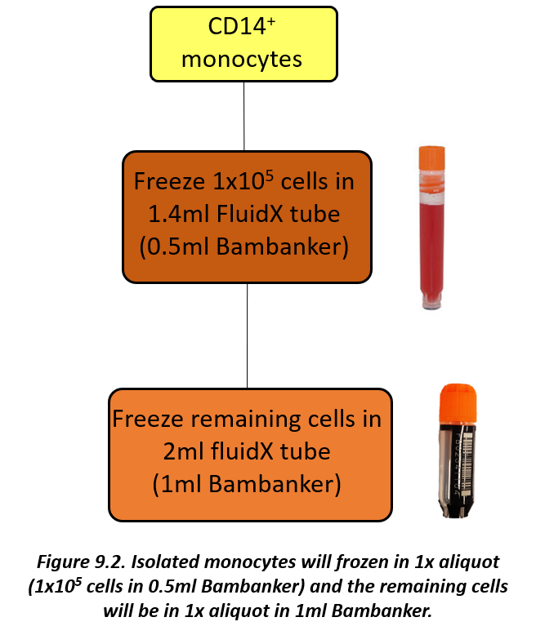

* The CD4+ T cells will be split equally and half will be frozen in Bambanker serum-free freezing medium, while the other half will be lysed in QIAzol Lysis Reagent as follows (see ***Figure 9.3***):
  + **1x aliquot** of **1x105 cells** in **0.5ml Bambanker** in a **1.4ml FluidX tube (blue caps)** for ATAC-seq.
  + **Remaining cells** split equally:
    1. Freeze **1x aliquot** in **1ml Bambanker** in **2ml FluidX tubes (orange caps – labelled “CD4+ T”)** for EpiSwitch and flow cytometry/CyTOF.
    2. Lyse in QIAzol Lysis Reagent (see **Cell lysis with QIAzol Lysis Reagent** section).

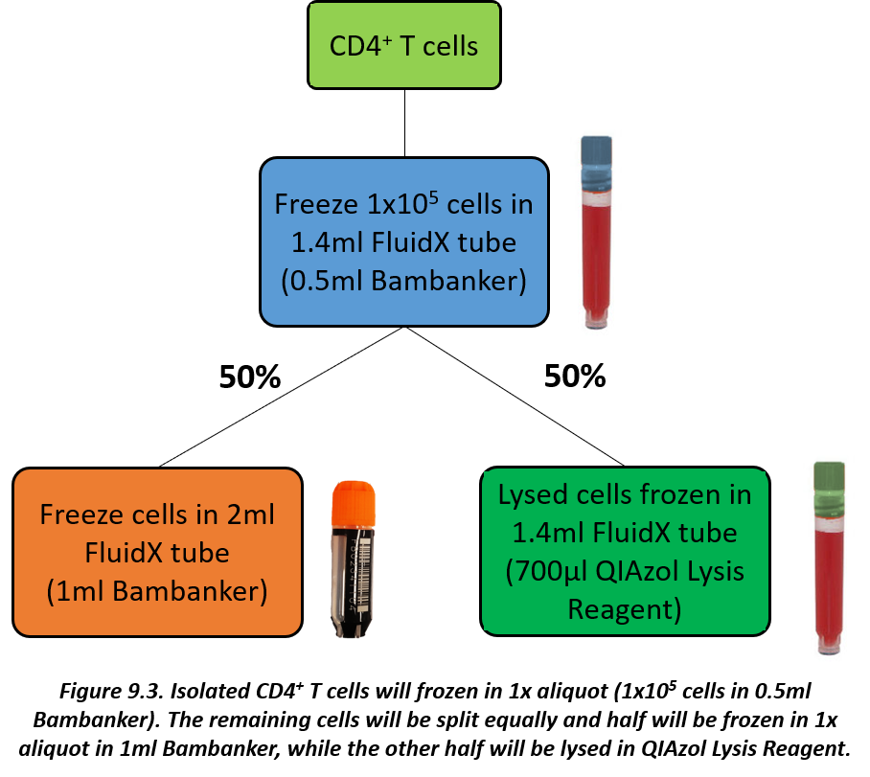

* When using Bambanker there is no need for step-wise temperature reductions, therefore a CoolCell or Mr Frosty is not required.

***Monocyte preparation***

1. Clearly write the date on **1x 1.4ml FluidX tube (amber caps)** and **1x 2ml FluidX tube (orange caps)** using a solvent resistant permanent marker pen.
2. Write “**CD14+**” on the 2ml FluidX tube (**orange caps**).
3. Based on the monocyte count from the **Quality Control Worksheet** calculate the volume of monocytes required to give 1x105 cells (record this on the **Quality Control Worksheet**). Transfer the calculated volume to a sterile 30ml universal tube labelled “CD14+ amber”. These monocytes are for downstream ATAC-seq analysis and will be stored in 0.5ml Bambanker in a 1.4ml FluidX tube (**amber caps**).
4. The remaining monocytes are for downstream epigenetic analysis and will be stored in 1ml Bambanker in a 2ml FluidX tubes (**orange caps – labelled “CD14+”**). Based on the monocyte count from the **Quality Control Worksheet** calculate the number of cells remaining and record this number on the **Quality Control Worksheet** as the number of cells per frozen aliquot.

***CD4+ T cell preparation***

1. Clearly write the date on **1x 1.4ml FluidX tube (blue caps)** and **1x 2ml FluidX tube (orange caps)** using a solvent resistant permanent marker pen.
2. Write “**CD4+ T**” on the 2ml FluidX tube (**orange caps**).
3. Based on the CD4+ T cell count from the **Quality Control Worksheet** calculate the volume of CD4+ T cells required to give 1x105 cells (record this on the **Quality Control Worksheet**). Transfer the calculated volume to a sterile 30ml universal tube labelled “CD4+ T blue”. These CD4+ T cells are for downstream ATAC-seq analysis and will be stored in 0.5ml Bambanker in a 1.4ml FluidX tube (**blue caps**).
4. Split the remaining cells equally by transferring half the volume of cells to a sterile 30ml universal tube (labelled “CD4+ T green“). Store these cells on **ice or at 4°C**. These CD4+ T cells will be lysed in in QIAzol Lysis Reagent (see **Cell lysis with QIAzol Lysis Reagent** section).
5. The other half of the CD4+ T cells will be stored in 1ml Bambanker in a 2ml FluidX tube (**orange caps – labelled “CD4+ T”**). Based on the CD4+ T cell count from the **Quality Control Worksheet** calculate the number of cells remaining and record this number on the **Quality Control Worksheet** as the number of cells per frozen aliquot.

***Freezing cells***

1. Top-up the 30ml universal tube containing the monocytes (x2 tubes labelled “CD14+ amber” and “CD14+”) and CD4+ T cells (x2 tubes labelled “CD4+ T blue” and “CD4+ T”) for freezing with cold PBS.

**N.B.** The **maximum volume** for the 30ml universal tubes is **25ml**.

1. Centrifuge the cells at **400g** for **6 minutes**, **4°C, brake on**.
2. Aspirate or pour off the supernatant and loosen the cell pellet thoroughly by flicking the tube.
3. Resuspend the cells in Bambanker as follows:

* **1x105 monocytes** for **ATAC-seq**

1. Add 0.5 ml of Bambanker.
2. Transfer the 0.5ml resuspended cells to **1x 1.4ml FluidX tube (amber caps).** Therefore, **1x105 monocytes/0.5ml/tube** will be stored.
   * **Remaining monocytes** for **EpiSwitch**
     1. Add 1ml of Bambanker
     2. Transfer 1ml resuspended cells to **1x 2ml FluidX tubes (orange caps – labelled “CD14+”)**.

* **1x105 CD4+ T cells** for **ATAC-seq**

1. Add 0.5 ml of Bambanker.
2. Transfer the 0.5ml resuspended cells to **1x 1.4ml FluidX tube (blue caps).** Therefore, **1x105 CD4+ T cells/0.5ml/tube** will be stored.
   * **Other CD4+ T cells** for **EpiSwitch**
     1. Add 1ml of Bambanker
     2. Transfer 1ml resuspended cells to **1x 2ml FluidX tubes (orange caps – labelled “CD4+ T”)**.
3. Each FluidX tube has a unique 2D barcode and should be scanned into the LIMS prior to being stored at -80oC in the correct positions of FluidX storage boxes (8x12 for 1.4ml FluidX tubes and 6x8 for 2ml FluidX tubes) as indicated by the LIMS - see **BIO-FLARE** **Titian Mosaic Laboratory Inventory Management System Manual**). To help with the correct placement on tubes in already existing storage boxes in the freezer a **LIMS Tube Location sheet** (see ***Appendix 7***) may be filled out.
4. Immediately transfer the tubes to -80°C storage and record the time of freezing on the **Quality Control Worksheet**.
5. Transfer the FluidX storage boxes to the gas phase of liquid nitrogen for long term storage within 2-3 days and **update the storage location on LIMS** - see **BIO-FLARE** **Titian Mosaic Laboratory Inventory Management System Manual**).

**N.B.** Be careful that the frozen cell samples do not thaw. Transfer the cell samples on dry ice.

***Cell lysis with QIAzol Lysis Reagent***

* 50% of the isolated CD4+ T cells (see **CD4+ T cell isolation** section) will be lysed for downstream RNA extraction.
* RNA in cells is not protected after harvesting until the sample is disrupted and homogenized in the presence of RNase-inhibiting or denaturing reagents (QIAzol Lysis Reagent). Otherwise, unwanted changes in the gene expression profile will occur. **It is therefore important that samples are immediately disrupted and homogenised in QIAzol Lysis Reagent.**
* When using QIAzol Lysis Reagent work in a fume cupboard. Clean the work area, including pipettes (ideally these should be dedicated RNA work only pipettes), with **RNase AWAY Decontamination Reagent or similar reagent**, and use RNase, DNase, pyrogen-free **filter** pipette tips
* The procedures for cell processing and RNA protection should be carried out as quickly as possible.
* After disruption and homogenization in QIAzol Lysis Reagent, samples can be stored at –80°C for many months.

1. Clearly write the date on **1x 1.4ml FluidX tube (green caps)** using a solvent resistant permanent marker pen.
2. Record the lot number of the QIAzol Lysis Reagent on the **Quality Control Worksheet**.
3. Record the number of CD4+ T cells used for cell lysis on the **Quality Control Worksheet** (this will be identical to the number of CD4+ T cells frozen in the 2ml FluidX tube (**orange caps – labelled “CD4+ T”**).
4. Top-up the 30ml universal tube containing the CD4+ T cells (labelled “CD4+ T green”) for lysis with cold PBS.

**N.B.** The **maximum volume** for the 30ml universal tubes is **25ml**.

1. Centrifuge the tube containing the CD4+ T cells for **400g**, **4oC, 6 minutes**, **brake on**.
2. Carefully aspirate the supernatant and loosen the cell pellet thoroughly by flicking the tube.
3. Lyse the cells by adding 700µl QIAzol Lysis Reagent.
4. Mix thoroughly by pipetting and vortexing for 1 minute.
5. Carefully transfer the lysed cells to a 1.4ml FluidX tube (**green caps**) using RNase, DNase, pyrogen-free **filter** pipette tips.
6. Each tube has a unique 2D barcode and should be scanned into the LIMS prior to being stored at -80oC in the correct positions of a FluidX storage box (8x12) as indicated by the LIMS - see **BIO-FLARE** **Titian Mosaic Laboratory Inventory Management System Manual**. To help with the correct placement on tubes in already existing storage boxes in the freezer a **LIMS Tube Location sheet** (see ***Appendix 7***) may be filled out.
7. Immediately transfer the tubes to -80°C storage and record the time of freezing on the **Quality Control Worksheet**.

***Purity check by flow cytometry***

* 2 aliquots of 2x105 PBMC and 1 aliquot each of 2x105 isolated CD14+ monocytes and CD4+ T cells (see sections **PBMC preparation, CD14+ monocyte isolation** and **CD4+ T cell isolation**) stored in a flow cytometry plate at 4oC will be stained with a cocktail of fluorochrome conjugated antibodies to enable a purity check by flow cytometry.
* **Cells should be stained on the same day, fixed and can then be stored overnight at 4oC and acquired the following day.**
* Once stained each well will be transferred to a separate flow cytometry tube according to the following:

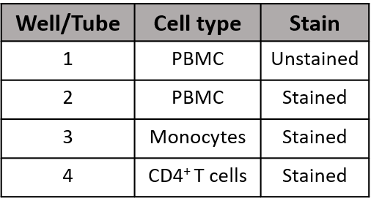

1. Record the lot numbers of each antibody on the **Quality Control Worksheet**.
2. Prepare 300µl Block consisting of 4µg/ml human IgG: 12µl 100µg/ml human IgG + 288µl FACS Wash Buffer in a 1.5ml microcentrifuge tube.
3. Prepare an antibody staining cocktail by mixing 4µl of each antibody listed in ***Table 9.1*** together in a 0.5ml microcentrifuge tube. This will give 1x excess antibody cocktail.

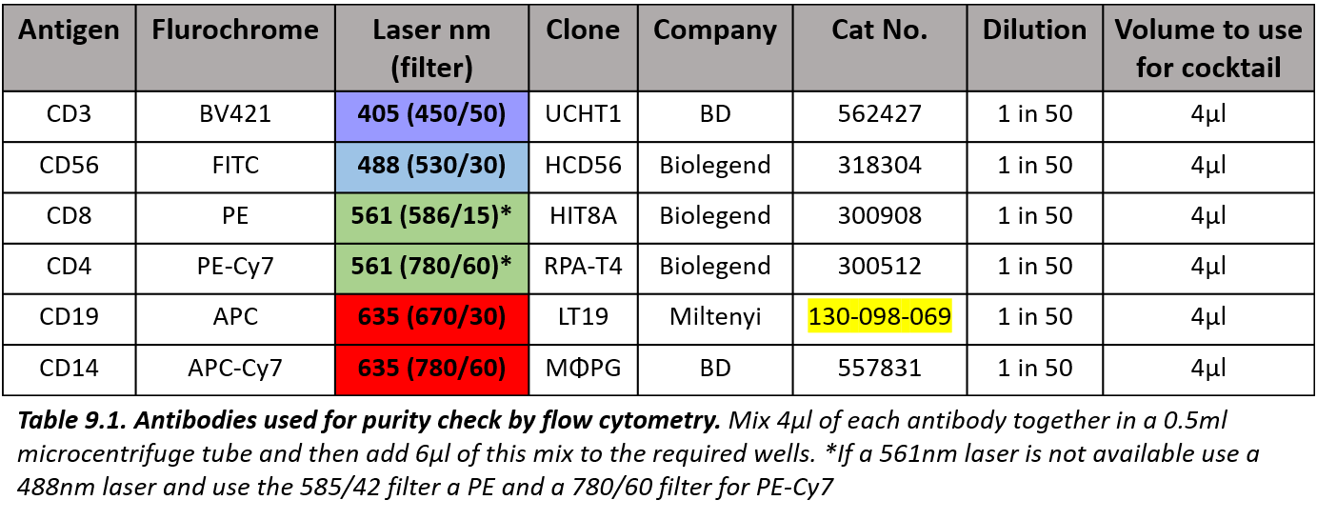

1. Centrifuge the flow cytometry plate containing the PBMC, monocytes and CD4+ T cells at **400g** for **3 minutes**, **brake on** at **room temperature.**

**N.B.** If the volume of the cells in each well is less than 100μl add FACS Wash Buffer to top the well up to at least 100μl. Be careful not to overfill the wells.

1. Discard the supernatant by flicking the plate over a sink then blot the plate on tissue.
2. Add 50µl Block to each well and pipette up and down to mix.

**N.B.** If the volume of cells to give 2x105 was over 200µl and was therefore split over two wells combine the cells into one well by adding 50µl Block to one well, pipetting to disrupt the cells, before removing this cell suspension and adding it to the second well containing the cells and pipetting to mix.

1. Add 6μl of the antibody staining cocktail prepared in step 2 to the wells for stained cells. For the unstained cells don’t add anything – this well will just contain PBMC in Block. Record the addition of the antibody staining cocktail on the **Quality Control Worksheet**.
2. Gently mix by pipetting and incubate at room temperature for 20 minutes, in the dark.
3. Add 100µl FACS Wash Buffer.
4. Centrifuge at **400g** for **3 minutes**, **brake on** at **room temperature.**
5. Discard the supernatant by flicking the plate over a sink.
6. Repeat the wash step in steps 8-10 using 200µl FACS Wash Buffer.
7. Add 200µl CellFix (**diluted from the original 10x concentrate 1:10 with distilled water**, i.e. **to make 1ml = 100µl 10x concentrate + 900µl distilled water** in a 1.5ml microcentrifuge tube) to each well and pipette to mix.

**N.B.** Make the CellFix fresh each time.

1. Transfer the contents of each well to a separate labelled flow cytometry tube.
2. Store the tubes at **4oC in the dark** and acquire on a suitable flow cytometer within 24 hours using an optimised and compensated experiment.
3. Once the cells have been acquired analyse the data to check cell purities. An example of the purity check gating strategy is displayed in ***Appendix 10***. Once analysed record the purity of the monocytes and CD4+ T cells on the **Quality Control Worksheet**. Send a copy of the **Quality Control Worksheet** and the FCS files to Amy Anderson at Newcastle (amy.anderson@ncl.ac.uk).
4. **Appendices**

* **Appendix 1 – Ordering information (blood and urine processing)**
* **Appendix 2 –** **BIO-FLARE IL-6 reagent sheet**
* **Appendix 3 - BIO-FLARE IFN-α2b reagent sheet**
* **Appendix 4 – BIO-FLARE Sample Summary sheet**
* **Appendix 5 - Smart Tube Quality Control Worksheet**
* **Appendix 6 -Smart Tube Barcode sheet**
* **Appendix 7 - LIMS Tube Location sheet**
* **Appendix 8 – Quality Control Worksheet**
* **Appendix 9 -** **Cell counting Protocols**
* **Appendix 10 - An example of a gating strategy for cell subset purity check**

**Appendix 1 – Ordering information (blood and urine processing)**

**Cytokine reconstitution and storage for Smart Tube stimulation**

|  |  |  |  |
| --- | --- | --- | --- |
| **Item** | **Supplier** | **Cat no.** | **Number needed per reconstitution** |
| Bovine serum albumin (BSA) | Sigma**\*** | A9647-50G**\*** | **0.25g** |
| Sterile Dulbecco’s Phosphate Buffered Saline (DPBS) (Ca2+/Mg2+ free) | SLS**\*** | LZBE17-512F**\*** | **66ml** |
| Sterile 50ml centrifuge tube | Greiner**\*** | 227261**\*** | **5** |
| 0.2μm syringe filter | Fisher**\*** | 10268401**\*** | **1** |
| 30ml syringe | SLS**\*** | SYR6011**\*** | **1** |
| Sterile deionised water | - | - | **500µl** |
| Sterile 0.5ml microcentrifuge tubes | Starlab**\*** | E1405-0600**\*** | **200** |
| Sterile 1.5ml microcentrifuge tubes (DNase and RNase free) | Starlab**\*** | E1415-1500**\*** | **13** |
| **Item** | **Supplier** | **Cat no.** | **Number needed per reconstitution** |
| Recombinant human IL-6, premium grade | **Supplied by Newcastle** (Miltenyi Biotec, cat no 130-095-352) | | **10µg** |
| Recombinant human IFN-α2b, research grade | **Supplied by Newcastle** (Miltenyi Biotec, cat no 130-093-875) | | **20µg** |

***\* or similar***

**Smart Tube stabilisation and storage of heparin blood**

|  |  |  |  |
| --- | --- | --- | --- |
| **Item** | **Supplier** | **Cat no.** | **Number needed per visit** |
| Smart Tubes | **Supplied by Newcastle** (Smart Tube, cat no MTS1P) | | **2** |
| Smart Tube storage box - Corning 10x5 rack | **Supplied by Newcastle** (SLS, cat no 431355) | | **1** |
| Cryo.s 5ml tubes (red caps) | **Supplied by Newcastle** (Greiner, cat no 124273) | | **2** |
| Cryo.s 5ml tubes (blue caps) | **Supplied by Newcastle** (Greiner, cat no 124274) | | **2** |

|  |  |  |  |
| --- | --- | --- | --- |
| **Item** | **Supplier** | **Cat no.** | **Number needed per visit** |
| Cryo rack for 48 Cryo.s tubes | **Supplied by Newcastle** (Greiner, cat no 803270) | | **1** |
| Recombinant human IL-6  **1μg/ml IL-6 master stock** | Miltenyi Biotec | 130-095-352 | **20µl of 1µg/ml master stock (prepared prior to sample processing)** |
| Recombinant human IFN-α2b  **2.5μg/ml IFN-α2b working stock** | Miltenyi Biotec | 130-093-875 | **30µl of 2.5µg/ml working stock (prepared prior to sample processing)** |
| Dulbecco’s Phosphate Buffered Saline (DPBS) (Ca2+/Mg2+ free) | SLS**\*** | LZBE17-512F**\*** | **190µl** |
| Sterile 0.5ml microcentrifuge tubes | Starlab**\*** | E1405-0600**\*** | **1** |
| Proteomic Stabilizer Buffer | **Supplied by Newcastle** (Smart Tube, cat no PROT1-1L) | | **5.6ml** |
| 30ml sterile polystyrene universal tube | StarLab**\*** | E14123010**\*** | **2** |

***\* or similar***

**Serum and urine processing**

|  |  |  |  |
| --- | --- | --- | --- |
| **Item** | **Supplier** | **Cat no.** | **Number needed per visit** |
| 1.4ml 2D barcoded internal thread screw top tube | **Supplied by Newcastle** (FluidX, cat no 66-52345) | | **12** |
| Red screwcap | **Supplied by Newcastle** (FluidX, cat no 66-63100-Y2) | | **6** |
| Yellow screwcap | **Supplied by Newcastle** (FluidX, cat no 66-63100-Y3) | | **6** |
| Storage box (8x12) - 96 well format high base rack with TwistLock, TubeLock and LidLock | **Supplied by Newcastle** (FluidX, cat no 66-51017) | | **1** |
| 0.2μm syringe filter | Fisher**\*** | 10268401**\*** | **1** |
| 10ml syringe | SLS**\*** | SYR6206**\*** | **1** |
| 30ml sterile polystyrene universal tube | StarLab**\*** | E14123010**\*** | **1** |

***\* or similar***

**Tempus Blood RNA tube storage**

|  |  |  |  |
| --- | --- | --- | --- |
| **Item** | **Supplier** | **Cat no.** | **Number needed per visit** |
| Storage box (7x7) - 49-Place 100mm High Cardboard Box | **Supplied by Newcastle** (StarLab, cat no A9627-4949) | | **1** |

**Preparation and storage of peripheral blood mononuclear cells**

|  |  |  |  |
| --- | --- | --- | --- |
| **Item** | **Supplier** | **Cat no.** | **Number needed per visit** |
| 2ml 2D barcoded cryo tube with external thread and jacket. Racked. Precapped with orange screw cap. “Production sterile” | **Supplied by Newcastle** (FluidX, cat no 65-7534) | | **6** |
| Storage box (6x8) - 48 Way Rack with LidLock | **Supplied by Newcastle** (FluidX, cat no 65-9451) | | **1** |
| 1.4ml 2D barcoded internal thread screw top tube | **Supplied by Newcastle** (FluidX, cat no 66-52345) | | **1** |
| White screwcap | **Supplied by Newcastle** (FluidX, cat no 66-63100-Y1) | | **1** |
| Storage box (8x12) - 96 well format high base rack with TwistLock, TubeLock and LidLock | **Supplied by Newcastle** (FluidX, cat no 66-51017) | | **1** |
| **Item** | **Supplier** | **Cat no.** | **Number needed per visit** |
| 50ml LeucoSep tube | Greiner | 227290 | **3** |
| Lymphoprep | Alere | 1114547 | **45ml** |
| Sterile 50ml centrifuge tube | Greiner**\*** | 227261**\*** | **3** |
| Sterile Dulbecco’s Phosphate Buffered Saline (DPBS) (Ca2+/Mg2+ free) | SLS**\*** | LZBE17-512F**\*** | **300ml** |
| 30ml sterile polystyrene universal tube | StarLab**\*** | E14123010**\*** | **2** |
| Bambanker serum-free freezing medium | Fisher | 13109155 | **6ml** |

***\* or similar***

**Isolation of cell subsets (monocytes and CD4+ T cells) using the Miltenyi MACS system**

|  |  |  |  |
| --- | --- | --- | --- |
| **Item** | **Supplier** | **Cat no.** | **Number needed per visit** |
| 96 well v-bottom well plate | Greiner**\*** | 651101**\*** | **1** |
| 2ml 2D barcoded cryo tube with external thread and jacket. Racked. Precapped with orange screw cap. “Production sterile” | **Supplied by Newcastle** (FluidX, cat no 65-7534) | | **2** |
| Storage box (6x8) - 48 Way Rack with LidLock | **Supplied by Newcastle** (FluidX, cat no 65-9451) | | **2** |
| 1.4ml 2D barcoded internal thread screw top tube | **Supplied by Newcastle** (FluidX, cat no 66-52345) | | **3** |
| Amber screwcap | **Supplied by Newcastle** (FluidX, cat no 66-63100-Y10) | | **1** |
| Blue screwcap | **Supplied by Newcastle** (FluidX, cat no 66-63100-Y4) | | **1** |
| Green screwcap | **Supplied by Newcastle** (FluidX, cat no 66-63100-Y8) | | **1** |
| Storage box (8x12) - 96 well format high base rack with TwistLock, TubeLock and LidLock | **Supplied by Newcastle** (FluidX, cat no 66-51017) | | **2** |
| **Item** | **Supplier** | **Cat no.** | **Number needed per visit** |
| Sterile Dulbecco’s Phosphate Buffered Saline (DPBS) (Ca2+/Mg2+ free) | SLS**\*** | LZBE17-512F**\*** | **125ml** |
| **MACS Buffer** (DPBS + 0.5% FCS + 2mM EDTA) | **-** | **-** | **150ml** |
| **To make 500ml:** | | |
| DPBS (Ca2+/Mg2+ free)- See above | See above | **500ml** |
| FCS – Sigma**\*** | F7524**\*** | **2.5ml** |
| Endotoxin free 0.5M EDTA – Sigma**\*** | E7889-100ML**\*** | **2ml** |
| 0.22 µm vacuum PES filter unit - Fisher**\*** | 10229090**\*** | **1** |
| Human CD14 MicroBeads | Miltenyi Biotec | 130-050-201 | **Dependent on number of PBMC** |
| Human CD4 MicroBeads | Miltenyi Biotec | 130-045-101 | **Dependent on number of PBMC** |
| LS positive selection column | Miltenyi Biotec | 130-042-401 | **2** |
| **Item** | **Supplier** | **Cat no.** | **Number needed per visit** |
| MidiMACS Separator | Miltenyi Biotec | 130-042-302**\*** | **1** |
| MACS MultiStand | Miltenyi Biotec | 130-042-303**\*** | **1** |
| 30ml sterile polystyrene universal tube | StarLab**\*** | E14123010**\*** | **7** |
| Bambanker serum-free freezing medium | Fisher | 13109155 | **3ml** |
| RNase AWAY Decontamination Reagent | Thermo Fisher**\*** | 10328011**\*** | **Enough to clean work space and equipment for QIAzol Lysis Reagent work** |
| QIAzol Lysis Reagent | QIAGEN | 79306 | **700µl** |
| 1.5ml microcentrifuge tubes (DNase and RNase free) | Starlab**\*** | E1415-1500**\*** | **2** |
| 0.5ml microcentrifuge tubes | Starlab**\*** | E1405-0600**\*** | **1** |
| **Item** | **Supplier** | **Cat no.** | **Number needed per visit** |
| **FACS Wash Buffer** (DPBS + 0.5% BSA + 1mM EDTA + 0.01% NaN3) | **-** | **-** | **5ml** |
| **To make 50ml:** | | |
| DPBS (Ca2+/Mg2+ free)- See above | See above | **50ml** |
| BSA – Sigma**\*** | A9647-50G**\*** | **0.25g** |
| Endotoxin free 0.5M EDTA – Sigma**\*** | E7889-100ML**\*** | **0.1ml** |
| NaN3 - Sigma**\*** | S2002-25G**\*** | **50µl of 10% solution**  (e.g. 10g dissolved in 100ml distilled water) |

|  |  |  |  |
| --- | --- | --- | --- |
| **Item** | **Supplier** | **Cat no.** | **Number needed per visit** |
| Human IgG  **Prepare a working stock at 100µg/ml in PBS** | Sigma**\*** | I2511-10MG**\*** | **12µl of 100µg/ml stock** |
| Anti-human CD3 BV421 (clone UCHT1) | BD | 562427 | **4µl** |
| Anti-human CD56 FITC (clone HCD56) | Biolegend | 318304 | **4µl** |
| Anti-human CD8 PE (clone HIT8A) | Biolegend | 300908 | **4µl** |
| Anti-human CD4 PE-Cy7 (clone RPA-T4) | Biolegend | 300512 | **4µl** |
| Anti-human CD19 APC (clone LT19) | Miltenyi | 130-098-069 | **4µl** |
| Anti-human CD14 APC-Cy7 (clone MØPG) | BD | 557831 | **4µl** |
| Distilled water | - | - | **1ml** |
| CellFix - 10x concentrate  **Dilute 1:10 with distilled water before use** | BD | 340181 | **0.1ml** |
| **Item** | **Supplier** | **Cat no.** | **Number needed per visit** |
| Flow cytometry tubes | SLS**\*** | 352054**\*** | **4** |

***\* or similar***

**Appendix 2 –****BIO-FLARE IL-6 reagent sheet**



**Appendix 3 –BIO-FLARE IFN-α2 reagent sheet**



**Appendix 4 –BIO-FLARE Sample Summary Sheet**

|  |  |  |  |
| --- | --- | --- | --- |
| **Date** | **Patient Study ID** | **Time Point** | **Processed by (initials)** |
|  |  |  |  |
|  |  |  |  |
|  |  |  |  |
|  |  |  |  |
|  |  |  |  |
|  |  |  |  |
|  |  |  |  |
|  |  |  |  |
|  |  |  |  |
|  |  |  |  |
|  |  |  |  |
|  |  |  |  |
|  |  |  |  |

**Appendix 5 - Smart Tube Quality Control Worksheet**



**Appendix 6 -Smart Tube Barcode sheet**

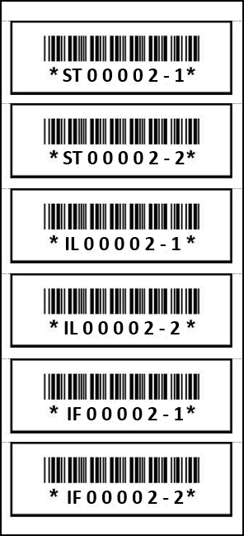

**Appendix 7 – LIMS Tube Location Sheet**



**Appendix 8 – Quality Control Worksheet**

**Appendix 9 – Cell counting Protocols**

**A. With a Burker counting chamber**

1. **Purpose**

* This SOP describes the step-by-step method to count cells in suspension.

1. **Procedure**
   1. **Material and equipment**

* Burker counting chamber (haemocytometer)
* Trypan Blue solution (Sigma-Aldrich, cat no T8154)
* Parafilm
* Phase contrast microscope with 40 x objective
  1. **Protocol**
  2. Mix 10µl of the cell suspension to count with 10µl trypan blue (dilution factor = 2) on a piece of parafilm.
  3. Press cover glass onto the slide until Newtons diffraction rings appear (rainbow-like rings).
  4. Fill one side of the counting chamber by touching the pipette tip at the interface of the slide and cover glass. The cell suspension will begin to be drawn in by capillary action. Fill the chamber, ensuring none of the cell suspension enters the channels surrounding the chamber and avoiding air bubbles.
  5. Count cells in the 25 small squares using a phase contrast microscope (40 x objective). Each small square is 0.2mm x 0.2mm, therefore you will count (0.2 x 0.2) x 25 = 1mm2 area.
  + Count cells which touch the upper and left border but not those which touch the lower and right borders (see ***Figure A1***).
  + For an accurate cell count a total of 25-100 cells should be counted in the 25 squares.
  + If the count of cells is above 100 events, then dilute the 10μl of cell suspension further with a volume of PBS before mixing 10µl diluted cells with 10µl trypan blue (e.g dilute 10μl of cell suspension with 20 μl PBS before mixing 10µl of the diluted cells with 10µl trypan blue to give a dilution factor = 6).
  1. Burker counting chamber: Depth: 0.1mm, count cells in 25 small squares (1mm2), therefore the count is for 1mm2 x 0.1mm = 0.1mm3 ≡ 0.0001ml:
* No. of cells in 25 squares x dilution factor x 104 = cells/ml
* Total number of cells = cells/ml x total volume

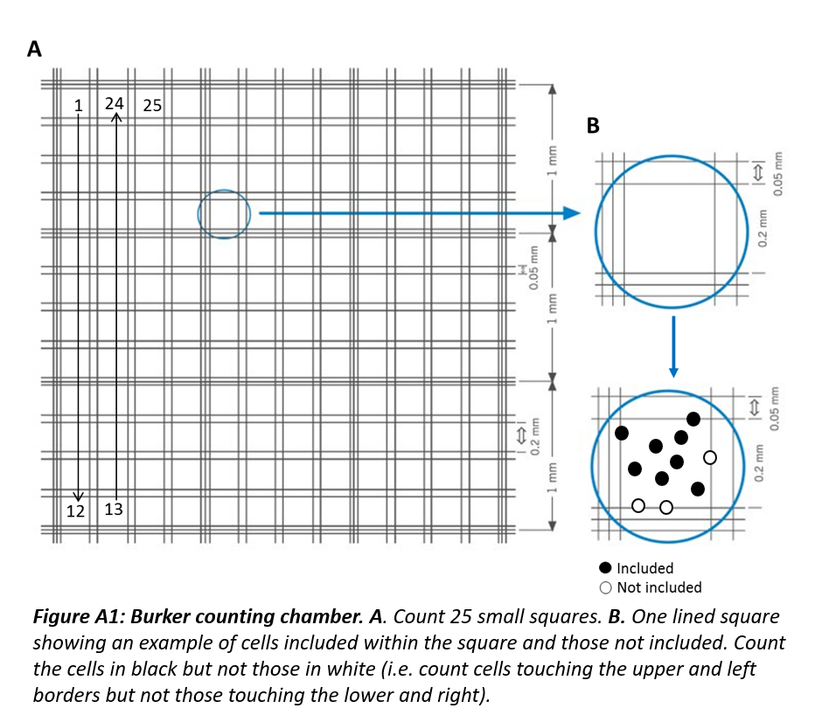

**B. With a Neubauer counting chamber**

1. **Purpose**

* This SOP describes the step-by-step method to count cells in suspension.

1. **Procedure**
   1. **Material and equipment**

* Neubauer counting chamber (haemocytometer)
* Trypan Blue solution (Sigma-Aldrich, cat # T8154)
* Parafilm
* Phase contrast microscope with 40 x objective
  1. **Protocol**

1. Mix 10µl of the cell suspension to count with 10µl trypan blue (dilution factor = 2) on a piece of parafilm.
2. Press cover glass onto the slide until Newtons diffraction rings appear (rainbow-like rings).
3. Fill one side of the counting chamber by touching the pipette tip at the interface of the slide and cover glass. The cell suspension will begin to be drawn in by capillary action. Fill the chamber, ensuring none of the cell suspension enters the channels surrounding the chamber and avoiding air bubbles.
4. Count cells in the 16 large corner squares using a phase contrast microscope (40 x objective). Each large square is 0.25mm x 0.25mm, therefore you will count (0.25 x 0.25) x 16 = 1mm2 area.
   * Count cells which touch the upper and left border but not those which touch the lower and right borders (see ***Figure B1***).
   * For an accurate cell count a total of 25-100 cells should be counted in 16 squares.
   * If the count of cells is above 100 events, then dilute the 10μl of cell suspension further with a volume of PBS before mixing 10µl diluted cells with 10µl trypan blue (e.g dilute 10μl of cell suspension with 20 μl PBS before mixing 10µl of the diluted cells with 10µl trypan blue to give a dilution factor = 6).
5. Neubauer counting chamber: Depth: 0.1mm, count cells in 16 large squares (1mm2), therefore the count is for 1mm2 x 0.1mm = 0.1mm3 ≡ 0.0001ml:

* No. of cells in 16 squares x dilution factor x 104 = cells/ml
* Total number of cells = cells/ml x total volume

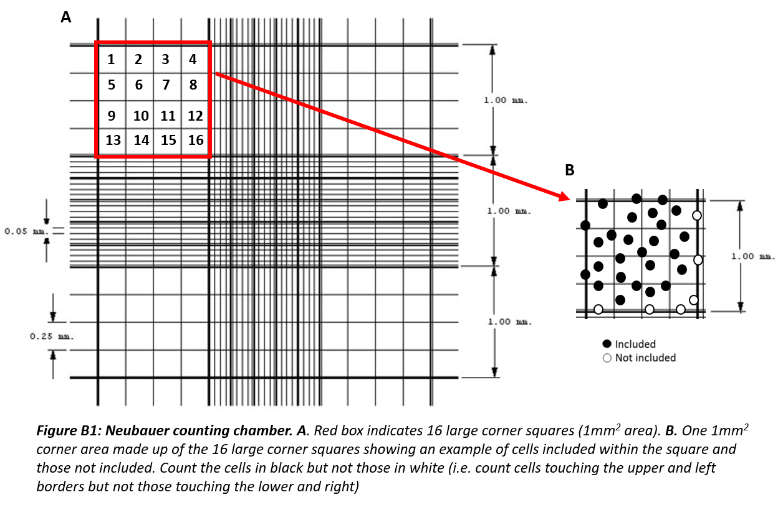

**Appendix 10 - An example of a gating strategy for cell subset purity check**

* + An example of the gating strategy to obtain monocytes and CD4+ T cell proportions in PBMC **pre-MACs** separation. The panel also assesses the proportion of CD8+ T cells, B cells and NK cells within the cell preparation:

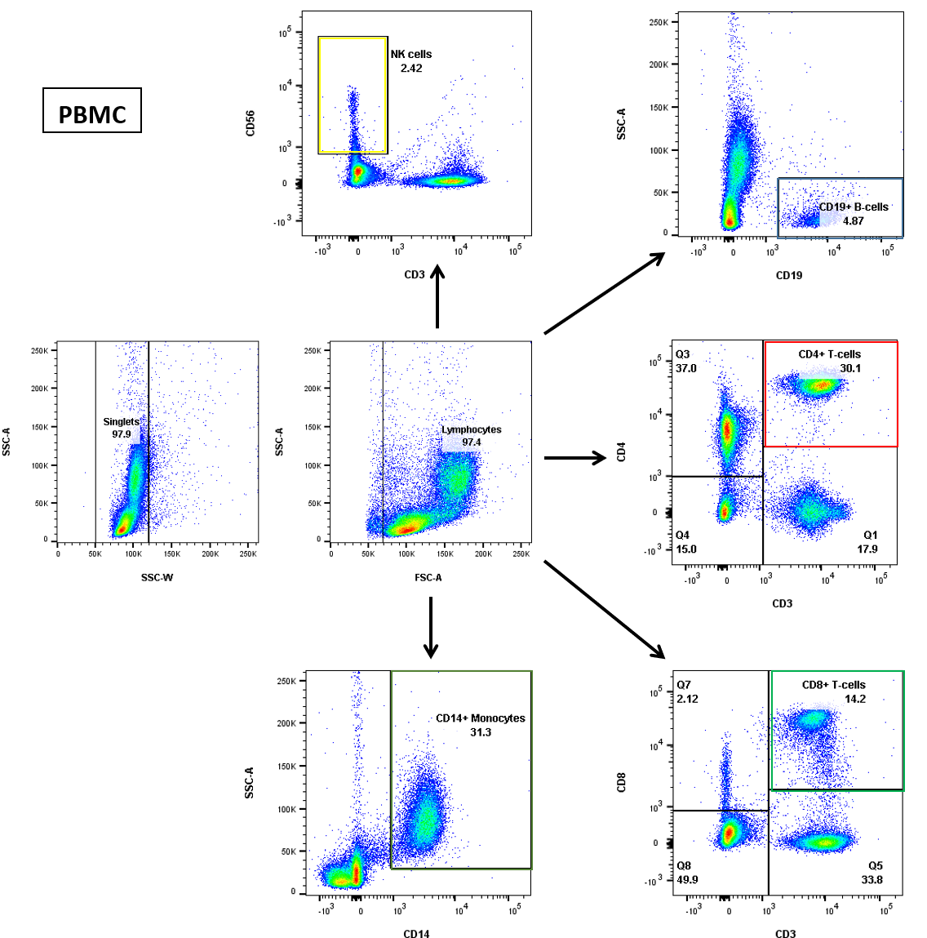

* + Examples of plots obtained **post-MACS**:

